BRIAN GRIFFIN PLANNING
& COUNTRYSIDE CONSULTANTS LIMITED
The Cottage, Green Bottom, Littledean
Gloucestershire GL14 3LH
Tel. 01594 829900
Vale of Glamorgan Council E-mail. btgriffin@myfwi.co.uk
Dock Office
Barry Docks
Barry
CF63 4RT

Date: 8 August 2022
Dear Sirs
Re Planning Application for Three Fishing Lakes and associated works Pant Wilkin Stables Aberthin Cowbridge CF71 7HE – Tim Vaughan Racing
Pre-Application Consultation (PAC) Report – major development
The pre-application report comprises the following:
Draft Application Form and Ownership Certificate
Pre-Application Enquiry Form
Brindle and Green Landscape Management Plan - Reference BG32.136.3
Brindle and Green Heritage Statement - Reference BG22.136
Bridle and Green Landscape Restraints Plan – Reference BG22.136.1
Brindle and Green Hard and Soft Landscaping Plan - Reference BG22 136.P02
Brindle and Green Landscape and Visual Impact Assessment – Reference BG22.136
SRK Consulting - Minerals Assessment
Mining Visibility Plan
ADL Traffic and Highways Engineering Limited - Transport Assessment
Vale Consulting Cut and Fill Analysis Drawing Number 15248_16
Vale Consultancy Site Cross Section 3 - 15248_103
Vale Consultancy Site Cross Section 2 - 15248_102
Vale Consultancy Site Cross Section 1 - 15248_101
Vale Consultancy General Arrangement - 15248_100
Waterco – Water Balance Assessment
Ros Willder - Preliminary Ecological Assessment
Ray Laverton - Agricultural Land Classification Report
Design and Access statement
Plan 21-012-b – Site Location Plan
Plan 21-012b—1- Existing Site Layout
Plan 21-012b –2 - Proposed Site Layout
Plan 21-012b-3b- 3D Images of Lakes
Plan 21-012b-4 – Artist’s Impression of Lakes
Plan 21-012b-5 - Pontoon Layout
Plan 21-012b-6 – Fishermen Amenities Hut

Supporting planning statement

Planning fee £1,000

This PAC Report is laid out as follows:

Paragraph 0 Introduction

Paragraph 1 The proposal

Paragraph 11 Access

Paragraph 15 Amount of development

Paragraph 16 Scale of development

Paragraph 17 Landscaping

Paragraph 22 Appearance

Paragraph 23 Context

Paragraph 24 Use

Paragraph 25 The development plan

Paragraph 26 Assessment of sustainable development -Tourism and leisure

Paragraph 27 Land classification

Paragraph 28 Ground profiling

Paragraph 29 Landscape and visual impact assessment

Paragraph 30 Transport

Paragraph 31 Ancillary works, pontoons, car parking and amenities hut

Paragraph 32 Scheduled monuments

Paragraph 33 Ecology

Paragraph 34 Drainage and water

Paragraph 35 Minerals

Paragraph 36 Conclusion

Paragraph 37 – Reference to Annexes for the most relevant policies and SLA description

0. Introduction - The applicant wishes to apply for Fishing Lakes with some associated development (reed beds, welfare unit, car parking area, landscaping) at Pant Wilkin Stables on 4.85 ha of land. The Vale Council’s protocol for major applications is given as:
Major Applications Housing developments of 10 or more dwellings or where the site area is of 0.5 ha or more (if the number of dwellings is not known);
• The provision of a building(s) where the floorspace created exceeds 1,000 sqm;
• The winning and working of minerals or the use of land for mineral-working deposits;
• Waste development; and

• Development carried out on a site of 1 ha or more - The application site is over 1 ha.

Pre-Application Consultation - Developers must submit a Pre Application Consultation (PAC) report for any “major” development. Detailed guidance can be found on the Welsh Government website Section 17 of the Planning Wales Act 2015
To assist developers in undertaking a community consultees and specialist consultees list has been produced of all Town / Community Councils and Ward Members and Specialist Consultees. The Council can assist developers in hosting information for their Pre-Application Consultation if they make a formal request for Pre-Application advice.
Notification of Commencement of Development
When a developer wishes to commence their major development, they must complete and submit a ‘Notification of initiation of development’ form.
In addition, a site notice and location plan must be displayed at the development from the date the development commences.
0.1 Discussions have taken place with the Vale Council regarding this proposed development. The Council has offered advice on the issues to be addressed through specialized reports and has suggested some amendments to the proposal which are considered below at paragraph 26.

- The proposal - The holding is a large Racing Yard for training of Flat and National Hunt race horses. It has re-structured in recent years with the best performing horses being stabled on a higher land site where ventilation is better. In addition it has added a mix of rural tourism and rural workshop type enterprises along with an equine veterinary clinic.
1.1 The applicant now wishes to further diversify his enterprise by adding a commercial fishing enterprise through the provision of three lakes carefully landscaped into a shallow valley near the A48 accessed by a recently approved route off the A48.
1.2 The three fishing lakes have an area of 1.7 ha and comprise linked lakes, each with an island. The applicant has six holiday log cabins just to the east of his lower Stable Yard where the Fishermen can stay whilst fishing. The site adjoins the eastern fringes of the Yard and would be served by the same access track and uses an area of land that is not used by the horses owing to it having been recently purchased. Two reed beds are also proposed which will provide biodiversity gains in addition to the fishing lakes. The reed beds will also act as a sink for any overflow of water and clean up any contaminates in the water. There are five wooden fishing pontoons each measuring 18.7 x 7.5 m and an Amenities Hut for the fishermen with a floor area of 18 m². A hardcored parking area for 18 vehicles will be provided near the amenities Hut. Some landscaping in the form of soft planting is proposed.
2. The applicant has taking advice from a course fishing expert with regards to the layout, sizing and design of the lakes to ensure they provide natural looking lakes that would attract fishermen but also appear as naturalised features with benefits for biodiversity. The lakes have shallow margins and mid sections being no more than a metre in depth along with deeper areas of 3.5 m – 4 m. The variation in depth is needed to provide suitable fish habitat during cold winters and hot summer weather.
- The lakes are formed through mainly a cut and fill operation thereby reducing the need for imported material. The sub-soil does not have enough clay in it to form a sealed surface to contain water, so some imported clay will be needed to seal the lake beds and also to provide a water catchment area that will feed water into the lakes so that water levels are maintained. The clay is rolled and consolidated to form an impervious base. The general layout of the site is given in the Plan below:
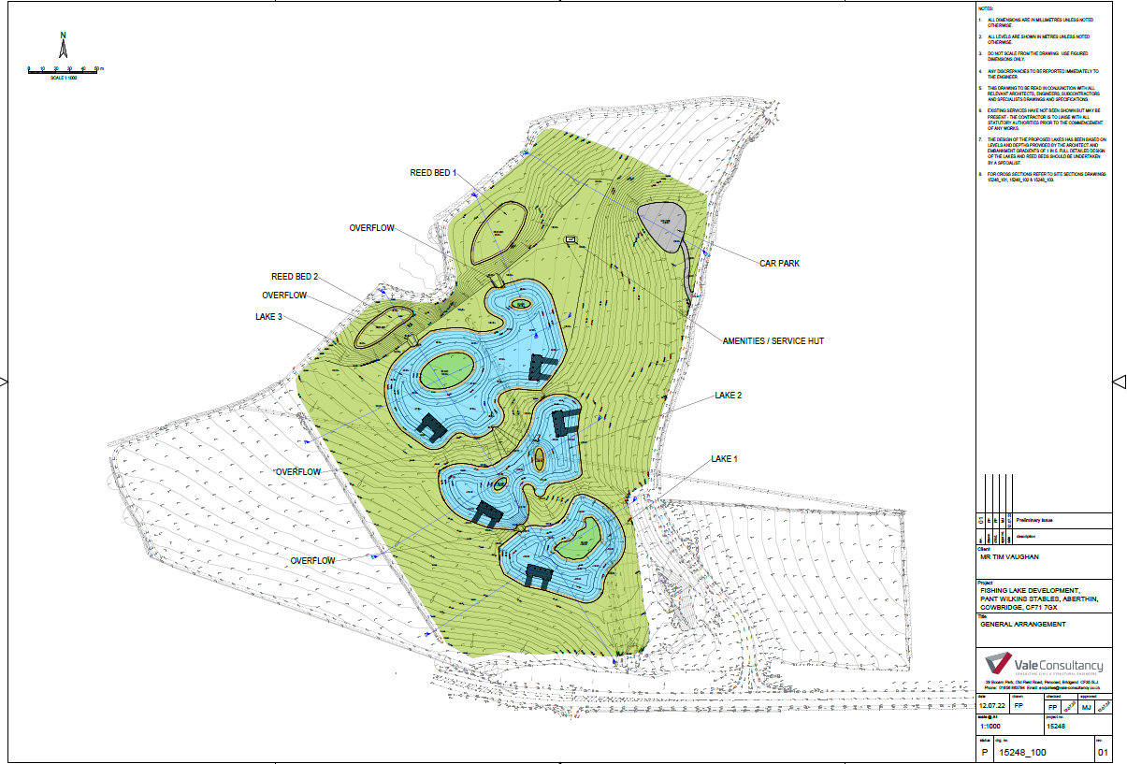
- The site lies outside any settlement boundary and in the countryside. It is just within the Upper and Lower Thaw Valley Special Landscape Area and within an area safeguarded for its limestone resources. The site has an agricultural land classification of mainly Grade 3b (moderate quality) with some 3a (good to moderate quality) land. Llanquian Castle and Llanquian Wood Camp Scheduled Monuments lie to the north of the site. There are also a number of archaeological records in the locality. There is a bridleway to the north of the site, along the southern edge of Llanquian Wood, which is a Site of Importance for Nature Conservation (SINC). Part of the site is identified as at risk from surface water flooding.
- The fishing lakes will remain open all year round during daylight hours so that they can cater for both tourists and locals. Night fishing will be allowed by prior arrangement as some of the higher calibre fishermen choose to fish all night. The ability to fish day or night will also help to attract clientele to the applicant’s holiday Cabins, that were recently approved and erected.
- Poaching of Carp can be an issue at remote fishing lakes. Therefore a CCTV system will be installed at the site’s entrance to monitor movement of vehicles.
- Three lakes are proposed so that different settings are provided for the fishermen. All three lakes will be mainly stocked with specimen carp and some smaller silver fish (Roach / Rudd / Dace). The upper lake will be managed as a nursery lake for young carp with surplus fish being transferred to the two lower, larger lakes.
- The fishermen will stand on wooden pontoons set at the lake edge. Five pontoons are proposed so the number of fishermen is restricted to maintain a semi natural ambience to the site.
- Fishermen can drive up to near the pontoons and park up their vehicles as fishermen tend to have a lot of equipment.
- The remainder of the field will be used for low key grazing with stock fencing preventing access for horses or other livestock to the lakes.

11. Access - The site is within the countryside, with a long well made access track off the A48 which has good east and west visibility. The Racing Stables were established in 2007 at a former livestock farmstead. It has stables, exercise tracks etc and grazing land to support a successful Racing Yard. The site is just inside the Thaw Valley Special Landscape Areas (Upper and Lower Thaw Valley). There are no PROW that pass through the application site.
13. Cowbridge is about 3 km to the south west and Aberthin Village is about 1.5 km to the north west. The locality has a scattering of dwellings and farmsteads. The Fishing Lakes site is in a shallow north facing valley close to the A48.
14. The access route is off a main distributor road (A48) via the recently approved new farm access. The parking and turning area is a short distance off the A48 and sited so as not to be prominent within the landscape.

15 Amount – The 1.7 ha lakes are set within a 4.85 ha site and the Fishermen’s Cabin has a floor area of 18 m². The Cabin is small scale in terms of height, i.e. 2.7 m at its highest point with a mono pitch roof finished in green. The five pontoons (wooden) from which the fishermen fish have each an area of 140 m² or 701 m2 in total. The hardcored parking area has 18 parking spaces.

16 Scale - The Cabin is 2.7 m high. A small scale building has been chosen so that it is ancillary to the Lakes and not overbearing.

17 Landscaping – The bunding between the lakes will be grassed over and a landscaping scheme has been proposed as shown on BG22 136.P02. The site is well screened from public viewpoints from the A48 and from Stalling Down where only long distance views (600 m) are seen of the site. There are no PROW passing through the site. The following photographs show the context of the site.
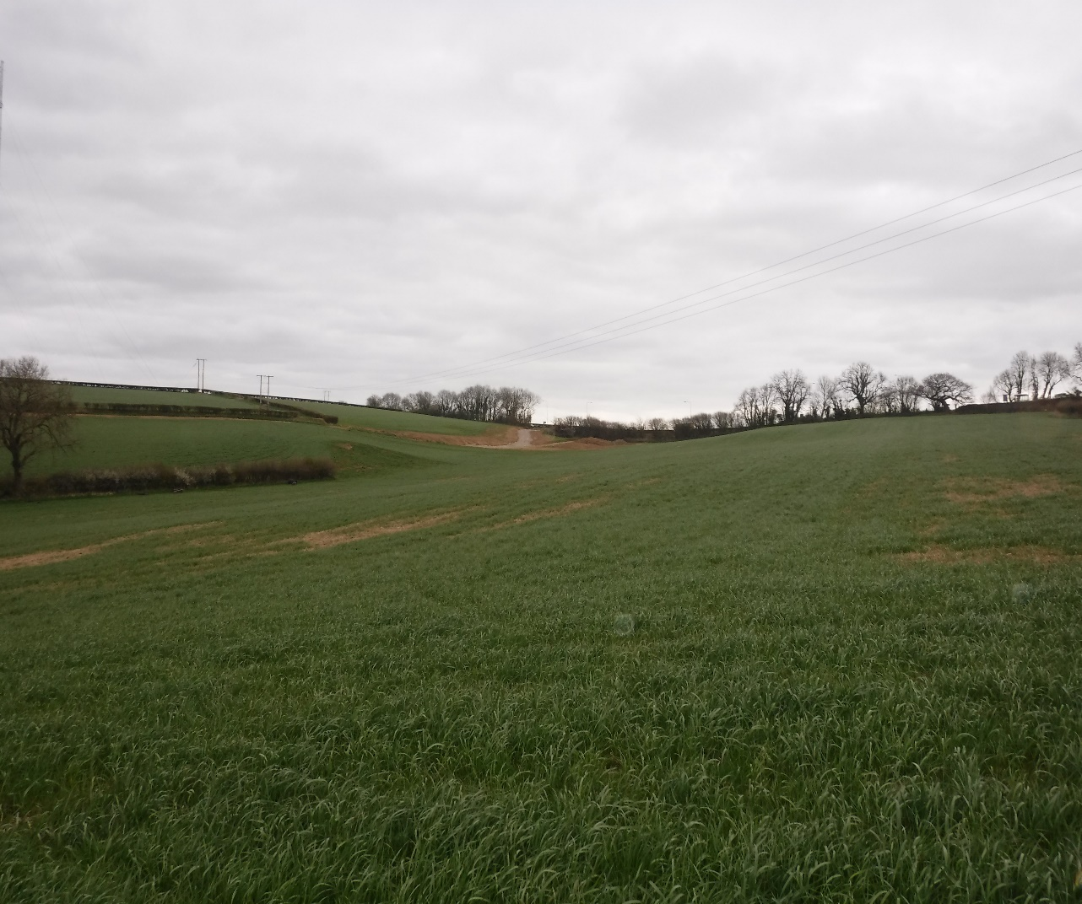
View of Lake Site from lower North East corner of field (looking towards the A48)

View of site from Entrance off the A48 with approved access
Site
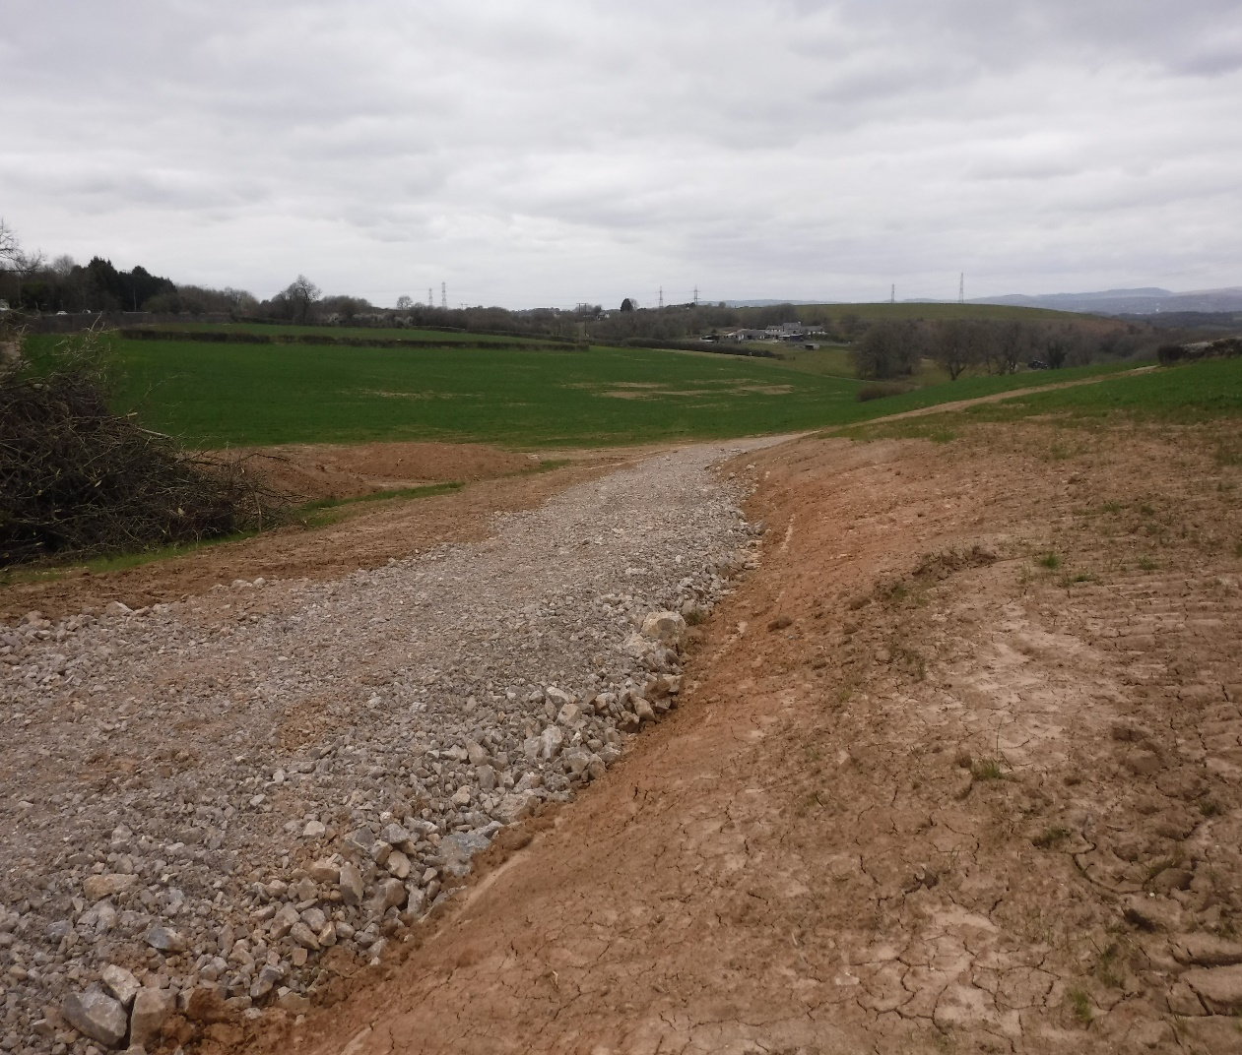
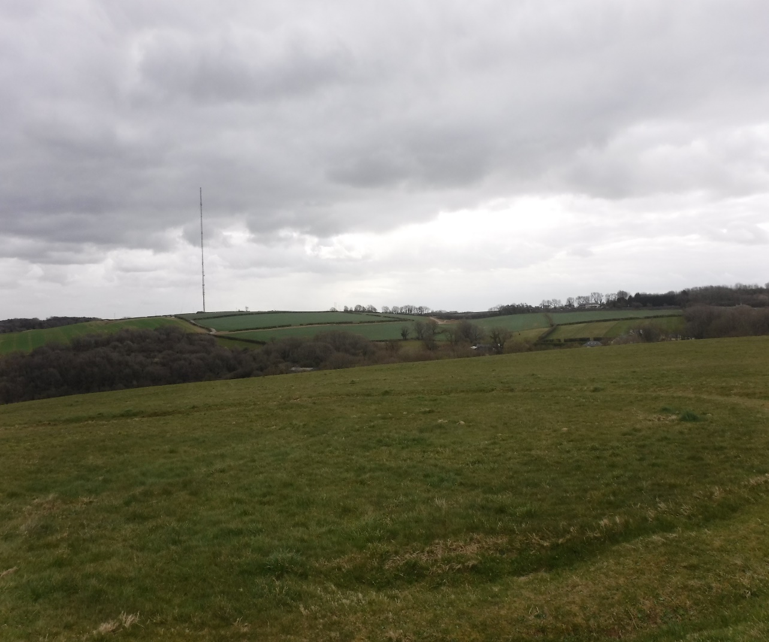
Site
View of Lake Site from Stalling Down (distant fields to right hand side of new farm track and Radio Aerial)
- The site is separated from the A48 by a mature dense hedgerow. Other than through the opening caused by the new access, the lakes would not be visible from the A48. A view of the site will be possible from Stalling Down some 600 m to the south east which affords panoramic views of the locality.

- The land has recently been purchased by the applicant and it was formerly used for arable cropping and pasture with no notable bio-diversity interest. An ecology walk over survey has been undertaken and is forwarded.

- There are no environmental, heritage or archaeological constraints identified at this site or nearby based on DEFRA’s MAGIC Map. The Llanquian Wood Heritage site is more than 150 m to the north.
- The site is set down within the upper slopes of a shallow valley and would be seen from Stalling down as a semi natural wet land site. The Fishing Lakes do make a change to the character of the site but one that has a natural appearance and one that blends in with the rolling landscape character of the site and locality. The Lakes and Reed Beds will add much bio-diversity value to the site. Detailed ecological and landscape assessments have been undertaken which are submitted with the pre-application report.

22. Appearance – The Lakes are formed following the natural ground contours within a shallow north west facing valley. When mature it will resemble a natural feature adding bio-diversity and rural enterprise to Pant Wilkin Stables. The fishing pontoons are wooden and float on the water. The Cabin is finished in timber boarding beneath a green felted type roof. The parking and turning area is finished in hardcore and the access track is existing. Landscaping makes use of indigenous species.

23. Context - The main valley through Pant Wilkin accommodates the Lower Racing Yard and is unsuitable for a fishing enterprise of the scale proposed. The proposed site is a natural shallow valley facing north west which can accommodate a series of fishing lakes using natural earth bunds a short distance from the A48. There are no near neighbours or conflict with PROW or sites of environmental importance. The sub soil was found to have insufficient clay to form a sealed base for the lakes so some imported clay will be used for that purpose. A topographical survey has been undertaken of the site and its environs and cross sections through the site have been undertaken and forwarded with the pre-application report.

24. Use – The proposed use is commercial fishing lakes to help diversify the Pant Wilkin Farm Stables enterprise. It is to be all year round and to include night fishing as that attracts the more serious fishermen.

25. The development plan - Planning decisions are made in accordance with the development plan unless material considerations indicate otherwise as required by Section 38 of The Planning and Compulsory Purchase Act 2004. The Vale of Glamorgan Adopted Local Development Plan 2011-2026 forms the local authority level tier of the development plan framework. The LDP was formally adopted by the Council on 28 June 2017, and within which the following policies are of relevance:

Strategic Policies:
POLICY SP1 – Delivering the Strategy
POLICY SP9 – Minerals
POLICY SP10 – Built and Natural Environment
POLICY SP11 – Tourism and Leisure

Managing Growth Policies:
POLICY MG17 – Special Landscape Areas
POLICY MG19 – Sites and Species of European Importance
POLICY MG20 – Nationally Protected Sites and Species
POLICY MG21 – Sites of Importance for Nature Conservation, Regionally Important Geological and Geomorphological Sites and Priority Habitats and Species
POLICY MG22 – Development in Minerals Safeguarding Areas
POLICY MG29 – Tourism and Leisure Facilities

Managing Development Policies:
POLICY MD1 - Location of New Development
POLICY MD2 - Design of New Development
POLICY MD7 - Environmental Protection
POLICY MD8 - Historic Environment
POLICY MD9 - Promoting Biodiversity
POLICY MD13 - Tourism and Leisure
POLICY MD17 - Rural Enterprise

In addition to the Adopted LDP the following policy, guidance and documentation
supports the relevant LDP policies.

Future Wales: The National Plan 2040:
Future Wales – the National Plan 2040 is the national development plan and is of relevance to the determination of this proposal. Future Wales provides a strategic direction for all scales of planning and sets out policies and key issues to be considered in the planning decision making process. The following chapters and policies are of relevance in the assessment of this proposal:
Chapter 3: Setting and achieving our ambitions. Future Wales’ outcomes are overarching ambitions based on the national planning principles and national sustainable placemaking outcomes set out in Planning Policy Wales.

Chapter 5 – The Regions
· The Vale of Glamorgan falls within the South East region.
· Regional policies provide a framework for national growth, for regional growth, for managing growth and supporting growth.
· In the absence of SDPs, development management process needs to demonstrate how Future Wales’ regional policies have been taken into account.
Policy 4 – Supporting Rural Communities
o Supports sustainable and vibrant rural communities.
Policy 5 – Supporting the Rural Economy
o Supports sustainable, appropriate and proportionate economic growth in rural towns.
o Supports development of innovative and emerging technology businesses and sectors to help rural areas unlock their full potential, broadening the economic base and creating higher paid jobs.
Policy 9 – Resilient Ecological Networks and Green Infrastructure
o Action towards securing the maintenance and enhancement of biodiversity (to provide a net benefit), the resilience of ecosystems and green infrastructure assets must be demonstrated as part of development proposals through innovative, nature-based approaches to site planning and the design of the built environment.
Policy 12- Regional Connectivity
o Active travel must be an essential and integral component of all new developments.
o Where car parking is provided for new non-residential development a minimum of 10% of car parking spaces should have electric vehicle charging points.

Planning Policy Wales:
National planning policy in the form of Planning Policy Wales (Edition 11, 2021) (PPW) is of relevance to this proposal.
The primary objective of PPW is to ensure that the planning system contributes towards the delivery of sustainable development and improves the social, economic, environmental and cultural well-being of Wales.
The following chapters and sections are of particular relevance in the assessment of this proposal:

Chapter 2 - People and Places: Achieving Well-being Through Placemaking
· Maximising well-being and sustainable places through placemaking (key Planning Principles, national sustainable placemaking outcomes, Planning Policy Wales and placemaking)

Chapter 3 - Strategic and Spatial Choices
· Good Design Making Better Places
· Placemaking in Rural Areas
· Accessibility
· The Best and Most Versatile Agricultural Land
· Development in the Countryside (including new housing)
· Supporting Infrastructure
· Managing Settlement Form –Green Wedges

Chapter 4 - Active and Social Places
· Transport
· Recreational Spaces

Chapter 5 - Productive and Enterprising Places
· Economic Infrastructure (electronic communications, transportation
Infrastructure, economic development, tourism and the Rural Economy)

Chapter 6 - Distinctive and Natural Places
· Recognising the Special Characteristics of Places (The Historic Environment,
Green Infrastructure, Landscape, Biodiversity and Ecological Networks, Coastal Areas)
· Recognising the Environmental Qualities of Places (water and flood risk, air quality and soundscape, lighting, unlocking potential by taking a de-risking approach)

Technical Advice Notes:
The Welsh Government has provided additional guidance in the form of Technical Advice Notes. The following are of relevance:
• Technical Advice Note 5 – Nature Conservation and Planning (2009)
• Technical Advice Note 6 – Planning for Sustainable Rural Communities
• Technical Advice Note 12 – Design (2016)
• Technical Advice Note 13 – Tourism (1997)
• Technical Advice Note 16 - Sport, Recreation and Open Space (2009)
• Technical Advice Note 18 – Transport (2007)
• Technical Advice Note 23 – Economic Development (2014)
• Technical Advice Note 24 – The Historic Environment (2017)

Welsh National Marine Plan:
National marine planning policy is in the form of the Welsh National Marine Plan (2019) (WNMP). The primary objective of WNMP is to ensure that the planning system contributes towards the delivery of sustainable development and contributes to the Wales well-being goals within the Marine Plan Area for Wales. WNMP is of limited relevance in the assessment of this proposal.

Supplementary Planning Guidance:
In addition to the adopted Local Development Plan, the Council has approved Supplementary Planning Guidance (SPG). Some SPG documents refer to previous adopted UDP policies and to ensure conformity with LDP policies, a review is to be carried out as soon as is practicable following adoption of the LDP. The Council considers that the content and guidance of the adopted SPGs remains relevant and has approved the continued use of these SPGs as material considerations in the determination of planning applications until they are replaced or otherwise withdrawn.
The following SPG are of relevance:
• Biodiversity and Development (2018)
• Design in the Landscape (2006)
• Minerals Safeguarding (2018)
• Parking Standards (2019)
• Sustainable Development - A Developer's Guide (2006)
• Tourism and Leisure Development (2019)
• Travel Plan (2018)
• Trees, Woodlands, Hedgerows and Development (2018)

Other relevant evidence or policy guidance:
· Welsh Government Circular 016/2014: The Use of Planning Conditions for Development Management

Well-being of Future Generations (Wales) Act 2015
The Well-being of Future Generations Act (Wales) 2015 places a duty on the Council to take reasonable steps in exercising its functions to meet its sustainable development (or wellbeing) objectives. The document has been prepared in consideration of the Council’s duty and the “sustainable development principle”, as set out in the 2015 Act. In preparing the advice, the Council has sought to ensure that the needs of the present are met without compromising the ability of future generations to meet their own needs.

26. Assessment of sustainable development - Tourism and Leisure - Policy SP11 (Tourism and Leisure) of the Local Development Plan states that proposals which promote the Vale of Glamorgan as a tourism and leisure destination will be favoured and Policy MD13 (Tourism and Leisure) allows new or enhanced tourism proposals where the proposal is located within the key settlements, the service centre settlements, primary settlements and minor rural settlements; or forms part of a rural enterprise or farm diversification scheme or involves the conversion of an existing rural building in accordance with Policy MD11; or involves sustainable low impact tourism and leisure proposals in the countryside.
26.1 The proposed development would be a tourism / leisure development that is part of an existing rural enterprise, so in principle the proposed fishing lakes are an acceptable alternative use of land at this site. However, the proposal should comply with other policies in the Local Development Plan, in particular Policy MD1 (Location of New Development) and Policy MG17 (Special Landscape Areas) at this site.
26.2 The Council’s Tourism and Leisure Development Supplementary Planning Guidance provides further advice on what is considered acceptable tourism and leisure development. The SPD sets out the Council’s Objectives for the Vale’s tourism and Objectives 2, 4, 8 and 9 state:
4.3.3. Objective 2 aims “to ensure that development within the Vale of Glamorgan makes a positive contribution towards reducing the impact of and mitigating the adverse effects of climate change.” New tourism and leisure developments should therefore be accessible by a variety of sustainable means of travel and incorporate sustainable design and building solutions.
4 .3.4. Objective 4 refers to the protection and enhancement of the area’s historic, built and natural environment. The Vale of Glamorgan benefits from a significant number of these environmental assets which are highly valued by local residents and visitors alike.
4.3.5. Objective 8 seeks to “foster the development of a diverse and sustainable local economy that meets the needs of the Vale of Glamorgan and that of the South East Wales region.” In both urban and rural areas, tourism and leisure related development is an essential element in providing for a healthy, diverse, local and national economy. The LDP recognises this and favours proposals for new and improved sustainable tourism and leisure facilities in appropriate locations.
4.3.6. Objective 9 aims “to create an attractive tourism destination with a positive image for the Vale of Glamorgan, encouraging sustainable development and quality facilities to enrich the experience for visitors and residents”. This objective is supported by a suite of LDP policies that seek to protect and enhance the range and choice of existing tourism and leisure facilities in the Vale of Glamorgan.
26.3 In the broader context of the Tourism and Leisure Development SPD the proposed fishing lakes situated close to the A48 and on the fringes of Cowbridge and Aberthin would meet the broad objectives of the Council’s vision for tourism developments, subject to protection of acknowledged interests. Fishermen will travel by car to carry their equipment, so the need for a nearby Bus Stop is not required. In principle the proposed development is well supported by the tourism development policy and SPD.

27 Land classification - A detailed soil classification exercise has been undertaken (see Ray Laverton - Agricultural Land Classification Report for full details.) using soil auger borings and digging soil pits. The results show that the application site is predominantly grade 3b as shown in Plan ALC1 below.
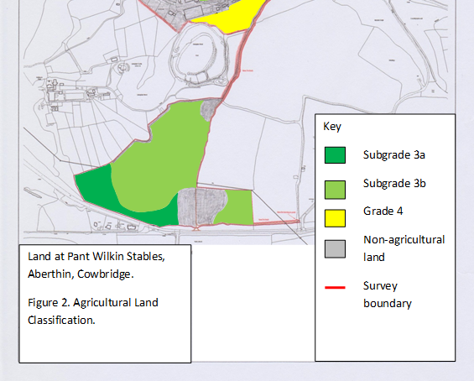
Agricultural Land Classification Report SITE
27.1 Most of the land within the site is grade 3b agricultural land. Policy MD1 (Location of Development) of the Local Development Plan requires that proposals on unallocated sites should have no unacceptable impact on the best and most versatile agricultural land. The best and most versatile land is defined as grades 1, 2 and 3a. The agricultural land survey shows that very little if any best and most versatile land will be lost due to the proposal. Criterion 9 of Policy MD1 is therefore satisfied. Even if the site included better grades of land fishing lakes will almost always be formed on agricultural land of varying grades. The loss of some higher grade land should not by itself make such a proposal be unacceptable.
27.2 With no high grade land lost, the formation of fishing lakes and reed beds has significant potential to provide biodiversity gains on the site. Therefore, subject to acceptable biodiversity gains being provided and other potential ecology impacts being addressed (see ecology section below) there should be no objection to the provision of fishing lakes in principle.
28. Reprofiling Works – Some ground reprofiling works is necessary to create the three tiered lakes and reed beds as they descend the shallow valley and which includes some reprofiling around the lakes to create a suitable environs to the lakes. The amount of reprofiling is kept to a minimum and cross sections through the site have been forwarded in Plans 15248 101, 102 and 103. The impact of these works has been assessed in the landscape and visual appraisal report.
28.1 Criterion 1 of Policy MD1 (Location of New Development) requires that developments should have no unacceptable impact on the countryside, and Policy MG17 (Special Landscape Areas) states that within special landscape areas, development proposals will be permitted where it is demonstrated they would cause no unacceptable harm to the important landscape character of the area.
28.2 Clearly some ground re-profiling will have some impact upon the character of the locality. The SLA description for the locality states that the Key Policy and Management Issues as
- Maintain hedgerow and tree cover.
- Incorporate agri-environment schemes.
- Improve development to ensure rural detailing and character.
- Restrict development in widely visible areas and introduce blocks of broadleaf woodland to integrate settlement/Ford related development.
- Encourage woodland management for continuous cover and pursue Forestry Commission Woodland Grant Schemes and Native Woodland Plans.
28.3 The submitted landscape and visual impact assessment (Reference BG22.136) has assessed the impact of the works and resultant lakes and reed beds and found the changes to be minor once the landscape mitigation works have been undertaken.
28.4 The SLA management issues does support rural developments that are not in visually prominent locations and the lakes once the worked areas have been grassed over and new soft plantings undertaken, would cause no unacceptable harm to the important landscape character of the area

29. Landscape and visual impact assessment - Detailed landscape and visual impact work has been undertaken along with land management and a proposed soft and hard landscaping scheme. This information is found in the following documents:
Brindle and Green Landscape Management Plan - Reference BG32.136.3
Brindle and Green Heritage Statement - Reference BG22.136
Bridle and Green Landscape Restraints Plan – Reference BG22.136.1
Brindle and Green Hard and Soft Landscaping Plan - Reference BG22 136.P02
Brindle and Green Landscape and Visual Impact Assessment – Reference BG22.136
29.1 There is some minor loss of existing green features, being a short section of hedgerow and a tree. The landscaping scheme does include tree and hedgerow planting that mitigates their loss, which is also a recommendation of the submitted preliminary ecological assessment.
29.2 Criterion 1 of Policy MD1 (Location of New Development) requires that developments should have no unacceptable impact on the countryside, and Policy MG17 (Special Landscape Areas) states that within special landscape areas, development proposals will be permitted where it is demonstrated they would cause no unacceptable harm to the important landscape character of the area.
29.3 With the proposed mitigation and management proposals the impact of the development on the landscape character is minor and the change is not seen as unacceptable. Indeed, a series of lakes and reed bed set within a shallow valley with new green planting will appear as a natural feature once the works start to mature and provide major bio-diversity gains.

30. Transport – ADL has undertaken an assessment of the vehicular use of the site once operational. Policies MD1 and MD2, (location and design of new development) require new developments to have access to or promote the use of sustainable modes of transport; provide a safe and accessible environment for all users, giving priority to pedestrians, cyclists and public transport users, and have no unacceptable impact on highway safety nor cause or exacerbate existing traffic congestion to an unacceptable degree.
30.1 Fishermen do not use public transport on account of the amount of kit they require. The access route has recently been approved via a separate planning application and it is safe for all road users. Many of the fishermen are expected to be staying on site in the approved holiday cabins. During the construction phase which would last 18 months) around 90,000 m³ of imported material is required for the lakes.
30.2 The Applicant confirms that the total volume of imported fill material required would be circa 90,000m³. This would be delivered to site via 8-wheel tipper lorries or articulated tippers over an 18-month period with a full-time dozer on site.
30.3 Based on the following reasonable assumptions, the number of construction vehicle trips can be predicted:
- Total fill material: 90,000m³
- Construction period: 360 days (20 working days per month for 18 months)
- Construction vehicle capacity: 15m³ - 33m³ (8-wheel tippers or arctic tippers)
- Total No. loads: 2,727 - 6,000 (90,000m³ ÷ 33m³ or 15m³)
- No. loads per day: 8 – 17
- No. loads per hour: 1 – 2 per hour (assuming 10hr working day)

31. Ancillary Works – The fishing lakes are supported by 5 wooden pontoons (each with an area of 140 m² an 18 m² amenities building 2.7 m high and a hardcored parking area for 18 vehicles with CCTV surveillance of the access. It is not envisaged that pathways will be required around the lakes as disabled access is not proposed other than at the pontoon closest to the car parking area. Fishermen will haul their equipment on their trolleys to the pontoons, which is normal practice.
31.1 Pontoons have been chosen in favour of individual fishing pints as overall we feel it has less impact than lots of small fishing points / platforms. In addition Match Fishing is not being proposed and groups of anglers like to fish near each other so that it becomes a group activity, rather than a solitary one.
31.2 The car park and amenities hut has been positioned away from the road so that they are on lower lying land and being distant from the access, reduces the chance of unwanted visitors and helps to tighten security of the site.
31.3 The scale of the ancillary works are overall, quite modest, low level and well landscaped. As such they are in compliance with Policy MD1 (Location of New Development) and Policy MG17 (Special Landscape Areas).
31.4 Where new structures and surfacing works are necessary and appropriate their designs and materials are chosen (timber decking and rails) which are suitable for the countryside location added to which is sympathetic landscaping providing more biodiversity gain.

32. Scheduled Monuments - A detailed heritage statement has been prepared under document reference BG22.136 as there are two scheduled monuments nearby and the Report identifies also that there is a Historic Battlefield and eleven Listed Buildings or Structures within 1 km of the site. The report concluded that due to existing and proposed visual screening within the surrounding landscape, and the distance from the site for some assets, impacts to both the significance and setting of identified assets is expected to result in ‘no harm’ to either of these factors. In addition, the nature of the proposed development comprising a fishing lake with limited built structures and associated landscaping is not expected to impact the appeal of the surrounding existing landscape in any significant degree. Further recommendations were not required due to the lack of impact by the proposed development.
32.1 Policy MD8 (historic environment) requires that development proposals must protect the qualities of the built and historic environment of the Vale of Glamorgan. There are no nearby listed buildings or conservation areas to be affected. With regards to the Llanquian Wood ancient monument policy MD8 says that development proposals must respect the special historic character and quality of these areas, their settings or historic views or vistas. There is no known archaeological remains at the site.
32.2 Llanquain Wood Camp and Llanquain Castle are scheduled monuments and are located 0.1 – 0.2km to the north of the site, with the significance of these assets deriving from their historical and archaeological interest. Both assets are located within dense woodland, and therefore not visible from the exterior. Direct impacts to this Scheduled Monument are not proposed and as such it is expected there will be ‘no harm’ to its significance.
32.3 Impacts to the setting of this asset by the proposed development are also anticipated to be minimal. Although within close proximity to the historic site, due to the elevation of the land within the site the Scheduled Monuments are not within visible range. The development of a fishing lake is not considered to be detrimental to the setting of the area, as such a development is fitting with the surrounding rural landscape. Therefore, there is considered to be ‘no harm’ on the setting of these assets by the proposed development.
32.3 We consider that policy MD8 is satisfied.

33. Ecology - The replacement of arable / improved grassland by lakes and reed beds provides huge opportunities to make significant biodiversity gains through the land management of the site. Policies MD7 and MD9 (environmental protection and promoting biodiversity) require that development will be required to demonstrate they will not result in an unacceptable impact on people, residential amenity, property and / or the natural environment and that new development proposals will be required to conserve and where appropriate enhance biodiversity interests.
33.1 A short section of species poor quality hedgerow will be removed and no designated sites will be adversely affected by this proposal, no priority habitats will be lost as part of this proposal and the habitat to be lost is unlikely to support any protected species. As both bats and birds have been recorded within the wider area a new native species rich hedgerow will be planted along the boundary of the site beside the permitted new access road to connect the site to the wider habitats and improve nesting and foraging habitat along the boundaries of the field as well as integral features for both bats and birds within the design of the cabin and no external lighting on the new cabin other than downlighters of less than 2 Lux.
33.2 The proposal will create a large area of reedbeds and three areas of open water. The design of the lakes will include emergent vegetation around them to provide added cover for wildlife & attract wetland insects, bats & birds.
33.3 In conclusion, this proposal has the potential to dramatically improve the wetland habitats and wildlife in the area and to provide long term enhancements for both wildlife and the local landscape.
33.4 As well as significant new hedge planting integral bird and bat boxes will be included in the amenities hut by the lakes to provide permanent enhancements for the locally recorded species. The creation of the lakes and reedbeds and the planting of native wetland plants will provide a magnet for a wide range of wildlife and ensure a wide biodiversity gain for wildlife.
33.4Not all the attracted wildlife are welcomed and vermin such as mink and rats will be monitored through using baited traps and any vermin caught will be humanely destroyed. Herons and cormorants can become an issue and if so, advice will be sought from the appropriate authorities.
33.5 Consequently policies MD7 and MD9 are very well supported by the development.

34. Drainage and water - The lakes will hold relatively large volumes of water and a Water Balance Assessment is provided which includes detailed water catchment modelling to ensure that that extraction of water does not have negative impacts on water courses or aquifers and their associated biodiversity.
34.1 Polices MD1 (location of development), MD2 (design of new development) and MD7 (environmental protection) require that development should not have any unacceptable impact upon the environment, including provide a positive context for the management of the water environment by avoiding areas of flood risk in accordance with the sequential approach set out in national policy and safeguard water resources and prevent any unacceptable impact upon the environment from pollution, affect upon ground water or the wider water regime.
34.2 The drainage report addresses various options for sourcing and supplying water to the lakes. Because the subsoil does not have sufficient clay to form an impervious base it is necessary to import some clay to make the lakes waterproof and to line a catchment area with clay so that sufficient runoff is fed into the lakes.
34.3 Of the options considered the use of clay in and around the lakes is considered to be the best way to assure a sufficient and continuous supply of water through the lakes without resorting to taking ground water or riparian water which may have a knock on affect upon the environment.
34.4 The import of clay does have a short term impact upon the environment in terms of vehicle movements, but otherwise the proposed method of water capture and throughflow will not have any unacceptable impact upon the environment and policies MD1, MD2 and MD7 are satisfied.

35. Minerals – The site area including the clay surfaced land overlies limestone, a protected mineral source in the Vale of Glamorgan. A minerals assessment report has been prepared by SRK Consulting along with a minerals visibility plan to show what impact, if any, the development may have on the safeguarding of such resources, in order to comply with Policy MG22 (Development in Mineral Safeguarding Areas) of the Local Development Plan.
35.1 The assessment has been carried out in accordance with the advice given in the Council’s Minerals Safeguarding Supplementary Planning Guidance. Policy MG22 says: New development will only be permitted in an area of known mineral resource where it has first been demonstrated that:
1. Any reserves of minerals can be economically extracted prior to the commencement of the development; or
2. extraction would have an unacceptable impact on environmental or amenity considerations; or
3. The development would have no significant impact on the possible working of the resource by reason of its nature or size; or
4. The resource in question is of poor quality / quantity.”
35.2 SRK having evaluated the issue do not consider the site to represent a viable commercial mineral resource. Application of a 200 m buffer from sensitive developments and historical sites prevents extraction of limestone from most of the site, with very little potential limestone resource remaining. Whilst a 200 m buffer is considered a minimum, it is likely that a larger buffer would be required to allow safe operation of existing businesses such as the Pant Wilkins Stables, likely excluding the whole of this site as safely exploitable.
35.3 Operation of mineral workings at the site would also introduce significant and unacceptable environmental detriments, such as noise, vibration and air pollution. Given the availability of high-quality limestone resources within The Vale of Glamorgan, the site is of a size and scale which would have a negligible impact with respect to sterilising an exploitable mineral resource.
35.4 As such, SRK concluded that the proposed development is exempt from mineral safeguarding and policy MG22 is not harmed.

36. Conclusion – A very detailed and comprehensive set of surveys and reports has been undertaken to ascertain whether the proposed development is sustainable development.
36.1 the driving force for the development is change. Change arising from the aftermath of Covid 19, BREXIT, Climate Change and the drive for rural diversification to future proof the business.
36.2 The site is located in a very sustainable location with a very good access onto the A48. It will provide a new dedicated coarse fishing site and deliver major biodiversity benefits.
36.3 The development plan and National Guidance strongly supports suitable rural diversification and the detailed reports propose where necessary mitigation to offset any likely harm to the landscape character and environmental impact.
36.4 Once established over an eighteen month period the lakes will provide an additional income stream for the wider Pant Wilkin Stables that marries well with the holiday lodges erected a couple of years ago.

36.5 The applicant is understanding of the need to satisfy the various consultees and looks forward to receiving their comments. We ask that any issues are raised at an early stage so that the matter can be addressed promptly.

37. Annexes
Annex A gives the most relevant policies and Annex B the Thaw SLA descriptions.
BRIAN GRIFIFN FRICS FAAV
Chartered Surveyor

APPENDIX A
PLANNING POLICIES
Local Development Plan:
Section 38 of The Planning and Compulsory Purchase Act 2004 requires that in
determining a planning application the determination must be in accordance with the
Development Plan unless material considerations indicate otherwise. The Vale of
Glamorgan Adopted Local Development Plan 2011-2026 forms the local authority
level tier of the development plan framework. The LDP was formally adopted by the
Council on 28 June 2017, and within which the following policies are of relevance:

future generations to meet their own needs.
The main development control polices are:
POLICY SP1 - DELIVERING THE STRATEGY The strategy will seek to improve the living and working environment, promote enjoyment of the countryside and coast and manage important environmental assets. This will be achieved by: 1. Providing a range and choice of housing to meet the needs of all sectors of the community; 2. Promoting a range of employment sites intended to meet the needs of the Vale of Glamorgan and the wider capital region; 3. Reinforcing the role of Barry, service centre settlements and primary settlements as providers of cultural, commercial and community services; 4. Promoting sustainable transport; 5. Delivering key infrastructure linked to the impacts of development; 6. Protecting and enhancing the built, natural and coastal environment; LDP Strategy 3The Town and Country Planning (Local Development Plan)(Wales) Regulations 2005 Vale of Glamorgan Local Development Plan 2011 - 2026 : Written Statement 39 7 Promoting opportunities for sustainable tourism and recreation;
POLICY SP9 - MINERALS The local and regional need for the provision of a continuous supply of minerals will be achieved through: 1. Maintaining a minimum of 10 years land bank of hard rock throughout the plan period; including extended time periods to complete permitted extraction at existing sites; 2. Favouring proposals which promote the sustainable use of minerals and encourage the use of secondary and alternative resources; 3. The safeguarding of known resources of sandstone, limestone, sand and gravel (where these occur outside settlements), from permanent development that would unnecessarily sterilise them or hinder their future extraction; and 4. Safeguarding wharf facilities for the landing of marine dredged sand & gravel. d 8. Favouring development that promotes healthy living.
POLICY SP10 - BUILT AND NATURAL ENVIRONMENT Development proposals must
preserve and where appropriate enhance the rich and diverse built and natural environment and heritage of the Vale of Glamorgan including: 1. The architectural and / or historic qualities of buildings or conservation areas, including locally listed buildings; 2. Historic landscapes, parks and gardens; 3. Special landscape areas; 4. The Glamorgan Heritage Coast; 5. Sites designated for their local, national and European nature conservation importance; and 6.
Important archaeological and geological features.
POLICY SP11 - TOURISM AND LEISURE Proposals which promote the Vale of Glamorgan as a tourism and leisure destination will be favoured. Existing tourism and leisure facilities will be protected and enhanced, and favourable consideration will be given to proposals which: 1. Enhance the range and choice of the Vale of Glamorgan’s tourism and leisure opportunities, particularly through the provision of all year round facilities and a range and choice of visitor accommodation in appropriate locations; 2. Favour rural diversification and the local economy; and 3. Protect existing tourism assets and promote the sustainable use of the countryside and the Glamorgan Heritage Coast.
POLICY MG17 - SPECIAL LANDSCAPE AREAS The following areas are designated as special landscape areas: 1. Castle Upon Alun; 2. Upper & Lower Thaw Valley; 3. Ely Valley & ridge slopes; 4. Nant Llancarfan; 5. Dyffryn basin & ridge slopes; 6. Cwrt-yr-Ala basin. Within the special landscape areas identified above, development proposals will be permitted where it is demonstrated they would cause no unacceptable harm to the important landscape character of the area.
POLICY MG19 - SITES AND SPECIES OF EUROPEAN IMPORTANCE Development proposals likely to have a significant effect on a European site, when considered alone or in combination with other projects or plans will only be permitted where: 1. The proposal is directly connected with or necessary for the protection, enhancement and positive management of the site for conservation purpose; or 2. The proposal will not adversely affect the integrity of the site; 3. There is no alternative solution; 4. There are reasons of overriding public interest; and 5. Appropriate compensatory measures are secured. Managing Growth in the Vale of Glamorgan 20PPW Edition 9 (November 2016) paragraphs 4.8.14 to 4.8.18. 86 Vale of Glamorgan Local Development Plan 2011 - 2026 : Written Statement Contents Development proposals likely to have an adverse effect on a European protected species will only be permitted where: 1. There are reasons of overriding public interest; 2. There is no satisfactory alternative; and 3. The action authorised will not be detrimental to the maintenance of the population of the species concerned at a favourable conservation status in their natural range.
POLICY MG20 – NATIONALLY PROTECTED SITES AND SPECIES Development likely to have an adverse effect either directly or indirectly on the conservation value of a site of special scientific interest will only be permitted where it is demonstrated that: 1. There is no suitable alternative to the proposed development; and 2. It can be demonstrated that the benefits from the development clearly outweigh the special interest of the site; and 3. Appropriate compensatory measures are secured; or 4. The proposal contributes to the protection, enhancement or positive management of the site. Development proposals likely to affect protected species will only be permitted where it is demonstrated that: 1. The population range and distribution of the species will not be adversely impacted; 2. There is no suitable alternative to the proposed development; 3. The benefits of the development clearly outweigh the adverse impacts on the protected species; and 4. Appropriate avoidance, mitigation and compensation measures are provided.
POLICY MG21 – SITES OF IMPORTANCE FOR NATURE CONSERVATION, REGIONALLY IMPORTANT GEOLOGICAL AND GEOMORPHOLOGICAL SITES AND PRIORITY HABITATS AND SPECIES Development proposals likely to have an adverse impact on sites of importance for nature conservation or priority habitats and species will only be permitted where it can be demonstrated that: 1. The need for the development clearly outweighs the nature conservation value of the site; 2. Adverse impacts on nature conservation and geological features can be avoided; 3. Appropriate and proportionate mitigation and compensation measures can be provided; and 4. The development conserves and where possible enhances biodiversity
POLICY MG22 - DEVELOPMENT IN MINERAL SAFEGUARDING AREAS Known mineral resources of sandstone, sand and gravel and limestone are safeguarded as shown on the proposals map. New development will only be permitted in an area of known mineral resource where it has first been demonstrated that: 1. Any reserves of minerals can be economically extracted prior to the commencement of the development; 2. Or extraction would have an unacceptable impact on environmental or amenity considerations; or 3. The development would have no significant impact on the possible working of the resource by reason of its nature or size; or 4. The resource in question is of poor quality / quantity.
POLICY MG29 - TOURISM AND LEISURE FACILITIES The provision of all year round tourism and leisure facilities will be favoured. Land is allocated at the following locations for tourism related development: 1. Barry Island Pleasure Park, Whitmore Bay; 2. Land at Nell’s Point, Whitmore Bay; and 3. Land at Cottrell Park Golf Course
POLICY MD1 - LOCATION OF NEW DEVELOPMENT New development on unallocated sites should: 1. Have no unacceptable impact on the countryside; 2. Reinforce the role and function of the key settlement of Barry, the service centre settlements, primary settlements or minor rural settlements as key providers of commercial, community and healthcare facilities; 3. Where appropriate promote new enterprises, tourism, leisure and community facilities in the Vale of Glamorgan; 4. In the case of residential development, support the delivery of affordable housing in areas of identified need; 5. Have access to or promote the use of sustainable modes of transport; 6. Benefit from existing infrastructure provision or where necessary make provision for new infrastructure without any unacceptable effect on the natural or built environment; 7. Where possible promote sustainable construction and make beneficial use of previously developed land and buildings; 8. Provide a positive context for the management of the water environment by avoiding areas of flood risk in accordance with the sequential approach set out in national policy and safeguard water resources; and 9. Have no unacceptable impact on the best and most versatile agricultural land.
POLICY MD2 - DESIGN OF NEW DEVELOPMENT In order to create high quality, healthy, sustainable and locally distinct places development proposals should: 1. Be of a high standard of design that positively contributes to the context and character of the surrounding natural and built environment and protects existing features of townscape or landscape interest; 2. Respond appropriately to the local context and character of neighbouring buildings and uses in terms of use, type, form, scale, mix, and density; 3. Where appropriate, provide new or enhanced areas of public realm particularly in key locations such as town centres, major routes and junctions; 4. Promote the creation of healthy and active environments and reduce the opportunity for crime and anti-social behaviour. In the case of retail centres, developments should provide active street frontages to create attractive and safe urban environments; 5. Provide a safe and accessible environment for all users, giving priority to pedestrians, cyclists and public transport users; 6. Have no unacceptable impact on highway safety nor cause or exacerbate existing traffic congestion to an unacceptable degree; 7. Where appropriate, conserve and enhance the quality of, and access to, existing open spaces and community facilities; 8. Safeguard existing public and residential amenity, particularly with regard to privacy, overlooking, security, noise and disturbance; 9. Provide public open space, private amenity space and car parking in accordance with the council’s standards; 10. Incorporate sensitive landscaping, including the retention and enhancement where appropriate of existing landscape features and biodiversity interests; 11. Provide adequate facilities and space for the collection, composting and recycling of waste materials and explore opportunities to incorporate re-used or recyclable materials or products into new buildings or structures; and 12. Mitigate the causes of climate change by minimising carbon and other greenhouse gas emissions associated with their design, construction, use and eventual demolition, and include features that provide effective adaptation to, and resilience against, the current and predicted future effects of climate change.
POLICY MD7 - ENVIRONMENTAL PROTECTION Development proposals will be required to demonstrate they will not result in an unacceptable impact on people, residential amenity, property and / or the natural environment from either: 1. Pollution of land, surface water, ground water and the air; 2. Land contamination; 3. Hazardous substances; 4. Noise, vibration, odour nuisance and light pollution; 5. Flood risk and consequences; 6. Coastal erosion or land stability; 7. The loss of the best and most versatile agricultural land; or 8. Any other identified risk to public health and safety. Where impacts are identified the Council will require applicants to demonstrate that appropriate measures can be taken to minimise the impact identified to an acceptable level. Planning conditions may be imposed or legal obligation entered into, to secure any necessary mitigation and monitoring processes. In respect of flood risk, new developments will be expected to avoid unnecessary flood risk and meet the requirements of TAN15. No highly vulnerable development will be permitted within Development Advice Map (DAM) zone C2. Development will only be permitted in areas at risk of flooding where it can be demonstrated that the site can comply with the justification and assessment requirements set out in TAN15.
POLICY MD8 - HISTORIC ENVIRONMENT Development proposals must protect the qualities of the built and historic environment of the Vale of Glamorgan, specifically: 1. Within conservation areas, development proposals must preserve or enhance the character or appearance of the area; 2. For listed and locally listed buildings, development proposals must preserve or enhance the building, its setting and any features of significance it possesses; 3. Within designated landscapes, historic parks and gardens, and battlefields, development proposals must respect the special historic character and quality of these areas, their settings or historic views or vistas; 4. For sites of archaeological interest, development proposals must preserve or enhance archaeological remains and where appropriate their settings.
POLICY MD9 - PROMOTING BIODIVERSITY New development proposals will be required to conserve and where appropriate enhance biodiversity interests unless it can be demonstrated that: 1. The need for the development clearly outweighs the biodiversity value of the site; and 2. The impacts of the development can be satisfactorily mitigated and acceptably managed through appropriate future management regimes.
POLICY MD13 - TOURISM AND LEISURE Proposals for the development of new or enhanced tourism and leisure facilities will be permitted where the proposal: 1. Is located within the key settlement, the service centre settlements, primary settlements and minor rural settlements; or Managing Development in the Vale of Glamorgan Vale of Glamorgan Local Development Plan 2011 - 2026 : Written Statement 117 2. Forms part of a rural enterprise or farm diversification scheme; or 3. Involves the conversion of an existing rural building in accordance with Policy MD11; or 4. Involves sustainable low impact tourism and leisure proposals in the countryside; and Proposals that would result in the loss of existing tourism and leisure facilities will be resisted unless it can be demonstrated that there is a sufficient supply of facilities within the area to satisfy demand and/or the facility has been marketed and proven to be no longer economically viable.

POLICY MD17 - RURAL ENTERPRISE Proposals for the development of small scale employment uses that promote rural enterprise will be permitted where the proposal: 1. Is located within a minor rural settlement; or 2. Is part of a farm diversification scheme; or 3. Involves the conversion of an existing rural building in accordance with policy MD11. Proposals that would result in the loss of existing small scale employment uses will be assessed in accordance with acknowledges that there may be instances where sensitive infilling or minor extensions to groups of dwellings may be acceptable (in particular for affordable housing to meet local need).
Proposals for such development will be assessed against this national policy framework. Where new development is justified in the open countryside, relevant LDP policies will also apply such as Policies MD2 Design of New Development and MD10 Affordable Housing. In addition, national policy also makes provision for new rural enterprise dwellings and ‘one planet developments’ as exceptions for residential development in the open countryside and clear guidance on these types of development in set out in TAN 6 Planning for Sustainable Rural Communities (July 2010).”

ANNEX B Upper and Lower Thaw SLA
The north side of the valley through which Nant Aberthin runs is not covered by a high quality landscape policy. The southern side of the valley is designated as a SLA (Upper and Lower Thaw SLA.) The description of the SLA in the Council’s documents state:
To the north, the area is sparsely settled with small villages and several farms. The generally open landscape has high intervisibility and overlooks Bridgend, bordering the M4, and colouring the perception of the area. Mynydd Maendy wind farm to the north also has a visual impact on the sense of place. There are a number of pleasant views to well-managed fields and wooded areas, but these are affected in places by gappy hedgerows and housing development. Trees and hedgerows are declining in the area but introducing blocks of broadleaf woodland would help to integrate settlement, whilst future development should be restricted in widely visible areas. The dramatic valley form has distinctive steep wooded slopes and a strong sense of place and is relatively uncommon. It
is enclosed by a plateau landscape and has a strong relationship with Cowbridge.
The SLA boundary excludes Cowbridge, the suburbs of which are eroding the rural character. The town centre areas of historic and aesthetic value are protected by Conservation Area status. The valley to the south is a confined, sinuous lowland valley with steep wooded sides and hedgerowed field valley floor with streams and wet ditches contributing to biodiversity. The strong valley, semi-natural and planted broadleaf woodland, and juxtaposition with valley settlements is very attractive and one of the best examples of this landscape in the Vale. Woodland is fragmented in places and linkages should be created by pursuing the Forestry Commission’s Woodland Grant Scheme and Native Woodland Plans. Elsewhere the landscape is rolling lowland with some views out to the coast.
Key Policy and Management Issues
- Maintain hedgerow and tree cover.
- Incorporate agri-environment schemes.
- Improve development to ensure rural detailing and character.
- Restrict development in widely visible areas and introduce blocks of broadleaf woodland to integrate settlement/Ford related development.
- Encourage woodland management for continuous cover and pursue Forestry Commission Woodland Grant Schemes and Native Woodland Plans.
5.2 The Evaluation Matrix for the SLA rates the SLA area (which does not include the application site or the near surrounding land) the following rating:
Geological GL 282 High M M M L GL 298 Moderate H M H M GL 492 Outstanding O O
O O GL 514 Moderate M L L L GL 532 High H M M M GL 630 Moderate L L L L GL 658 High H M M M GL 709 Moderate L L L L GL 863 Moderate M M H M
Landscape Habitats LH 103 Low U U U U U U L M LH 118 Moderate L L H U L M M H LH 394 High H M U U U M H U LH 435 Moderate M L H U L L M U LH 436 High
H M U U U M H H LH 782 High H H U U U H H U LH 808 Moderate H H U U H M M H
Visual and Sensory VS 139 High H H H H VS 146 Moderate M M M M VS 161
Moderate M M M M VS 805 Moderate M M M M VS 864 Moderate M M H M VS
933 High H M H H VS 943 Moderate M M M M VS 962 Moderate H M M M
Historical Landscapes HL 022 Outstanding O O H H H HL 032 Outstanding O O H M O
HL 039 Outstanding O O M O O HL 040 Outstanding O O H O O HL 041
Outstanding O O O O O HL 042 High H H H L H HL 046 High H H H H M HL
047 High H H M M H HL 048 High H H H M M HL 049 High H H M L O HL 052 High H H M M H HL 053 Moderate M M M L M HL 054 High H H M M H
Cultural CL 008 Outstanding H M O U H H L H U CL 020 Outstanding H H L O H U M
U U CL 028 Outstanding M H L M O H L L U CL 037 Outstanding M H L M O H
L L U CL 039 High H O L U O H L H L

