BRIAN GRIFFIN PLANNING
& COUNTRYSIDE CONSULTANTS LIMITED
The Cottage, Green Bottom, Littledean
Gloucestershire GL14 3LH
Tel. 01594 829900
Vale of Glamorgan Council E-mail. btgriffin@myfwi.co.uk
Dock Office
Barry Docks
Barry
CF63 4RT

Date: 8 August 2022
Dear Sirs
Re Planning Application for Three Fishing Lakes and associated works Pant Wilkin Stables Aberthin Cowbridge CF71 7HE – Tim Vaughan Racing
Pre-application Consultation Report – major development
Design and Access Statement
The pre-application comprises the following:
Draft Application Form and Ownership Certificate
Pre-Application Enquiry Form
Brindle and Green Landscape Management Plan - Reference BG32.136.3
Brindle and Green Heritage Statement - Reference BG22.136
Bridle and Green Landscape Restraints Plan – Reference BG22.136.1
Brindle and Green Hard and Soft Landscaping Plan - Reference BG22 136.P02
Brindle and Green Landscape and Visual Impact Assessment – Reference BG22.136
SRK Consulting - Minerals Assessment
ADL Traffic and Highways Engineering Limited - Transport Assessment
Vale Consulting Cut and Fill Analysis Drawing Number 15248_16
Vale Consultancy Site Cross Section 3 - 15248_103
Vale Consultancy Site Cross Section 2 - 15248_102
Vale Consultancy Site Cross Section 1 - 15248_101
Vale Consultancy General Arrangement - 15248_100
Waterco – Water Balance Assessment
Ros Willder - Preliminary Ecological Assessment
Ray Laverton - Agricultural Land Classification Report
Design and Access statement
Plan 21-012-b – Site Location Plan
Plan 21-012b—1- Existing Site Layout
Plan 21-012b –2 - Proposed Site Layout
Plan 21-012b-3b- 3D Images of Lakes
Plan 21-012b-4 – Artist’s Impression of Lakes
Plan 21-012b-5 - Pontoon Layout
Plan 21-012b-6 – Fishermen Amenities Hut

Supporting planning statement

Design and Layout
1. The three fishing lakes have an area of 1.7 ha and comprise linked lakes, each with an island. The applicant has six holiday log cabins just to the east of the lower Stable Yard where the Fishermen can stay whilst fishing. The site adjoins the eastern fringes of the Yard and would be served by the same access track and uses an area of land that is not used much by the horses owing to having been recently purchased. Two reed beds are also proposed which will provide biodiversity gains in addition to the fishing lakes. The reed beds will also act as a sink for any overflow of water and clean up any contaminates in the water. There are five wooden fishing pontoons each measuring 18.7 x 7.5 m and an Amenities Hut for the fishermen with a floor area of 18 m². A hardcored parking area for 18 vehicles will be provided near the amenities Hut.
2. The applicant has taking advice from a course fishing expert with regards to the layout, sizing and design of the lakes to ensure they provide natural looking lakes that would attract fishermen but also appear as naturalised features with benefits for biodiversity. The lakes have shallow margins and mid sections being no more than a metre in depth along with deeper areas of 3.5 m – 4 m. The variation in depth is needed to provide suitable fish habitat during cold winters and hot summer weather.
- The lakes are formed through mainly a cut and fill operation thereby reducing the need for imported material. The sub-soil does not have enough clay in it to form a sealed surface to contain water, so some imported clay will be needed to seal the lake beds and also to provide a water catchment area that will feed water into the lakes so that water levels are maintained. The clay is rolled and consolidated to form an impervious base. The general layout of the site is given in the Plan below:
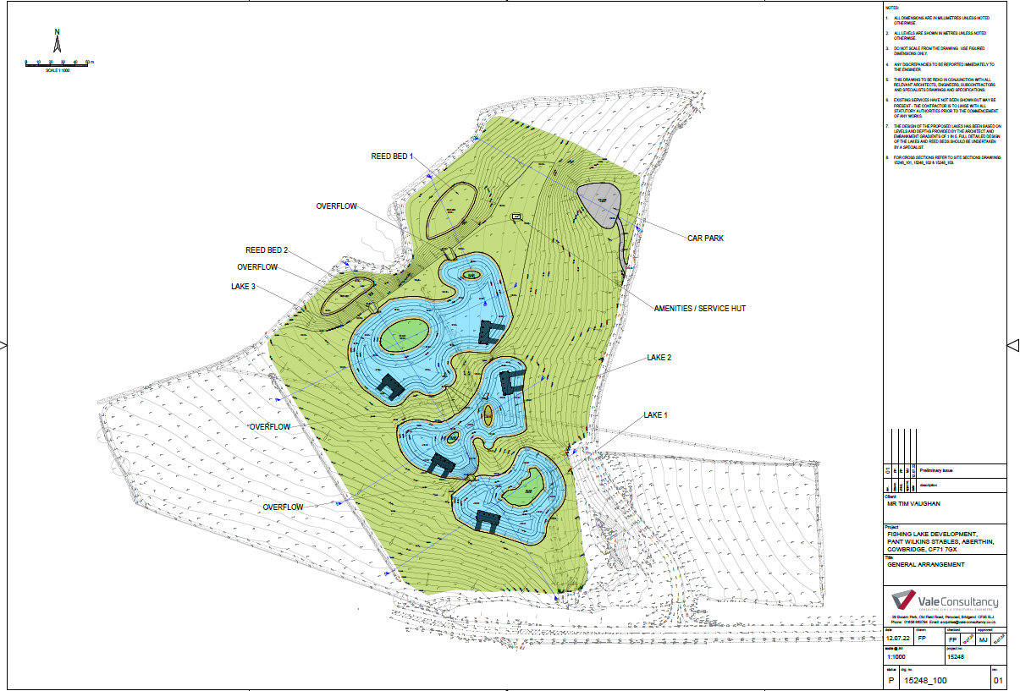
- The site lies outside any settlement boundary and in the countryside. It is just within the Upper and Lower Thaw Valley Special Landscape Area and within an area safeguarded for its limestone resources. The site has an agricultural land classification of mainly Grade 3b (moderate quality) with some 3a (good to moderate quality) land. Llanquian Castle and Llanquian Wood Camp Scheduled Monuments lie to the north of the site. There are also a number of archaeological records in the locality. There is a bridleway to the north of the site, along the southern edge of Llanquian Wood, which is a Site of Importance for Nature Conservation (SINC). Part of the site is identified as at risk from surface water flooding.
- The fishing lakes will remain open all year round during daylight hours so that they can cater for both tourists and locals. Night fishing will be allowed by prior arrangement as some of the higher calibre fishermen choose to fish all night. The ability to fish day or night will also help to attract clientele to the applicant’s holiday Cabins, that were recently approved and erected.
- Poaching of Carp can be an issue at remote fishing lakes. Therefore a CCTV system will be installed at the site’s entrance to monitor movement of vehicles.
- Three lakes are proposed so that different settings are provided for the fishermen. All three lakes will be mainly stocked with specimen carp and some smaller silver fish (roach / Rudd / Dace). The upper lake will be manage das a nursery lake for young carp with surplus fish being transferred to the two lower, larger lakes.
- The fishermen will stand on wooden pontoons set at the lake edge. Five pontoons are proposed so the number of fishermen is restricted to maintain a semi natural ambience to the site.
- Fishermen can drive up to near the pontoons and park up their vehicles as fishermen tend to have a lot of equipment.
- The remainder of the field will be used for low key grazing with stock fencing preventing access for horses or other livestock to the lakes.

11. Access - The site is within the countryside, with a long well made access track off the A48 which has good east and west visibility. The Racing Stables were established in 2007 at a former livestock farmstead. It has stables, exercise tracks etc and grazing land to support a successful Racing Yard. The site is just inside the Thaw Valley Special Landscape Areas (Upper and Lower Thaw Valley). There are no PROW that pass through the application site.
13. Cowbridge is about 3 km to the south west and Aberthin Village is about 1.5 km to the west. The locality has a scattering of dwellings and farmsteads. The Fishing Lakes site is in a shallow north facing valley close to the A48.
14. The access route is off a main distributor road (A48) via the recently approved new farm access. The parking and turning area is a short distance off the A48 and sited so as not to be prominent within the landscape.

15 Amount – The 1.7 ha lakes are set within a 4.85 ha site and the Fishermen’s Cabin has a floor area of 18 m². The Cabin is small scale in terms of height, i.e. 2.7 m at its highest point with a mono pitch roof finished in green. The five pontoons (wooden) from which the fishermen fish have each an area of 140 m² or 701 m2 in total. The hardcored parking area has 18 parking spaces.

16 Scale - The Cabin is 2.7 m high. A small scale building has been chosen so that it is ancillary to the Lakes and not overbearing.

17 Landscaping – The bunding between the lakes will be grassed over and a landscaping scheme has been proposed as shown on BG22 136.P02. The site is well screened from public viewpoints from the A48 and from Stalling Down where only long distance views (600 m) are seen of the site. There are no PROW passing through the site. The following photographs show the context of the site.
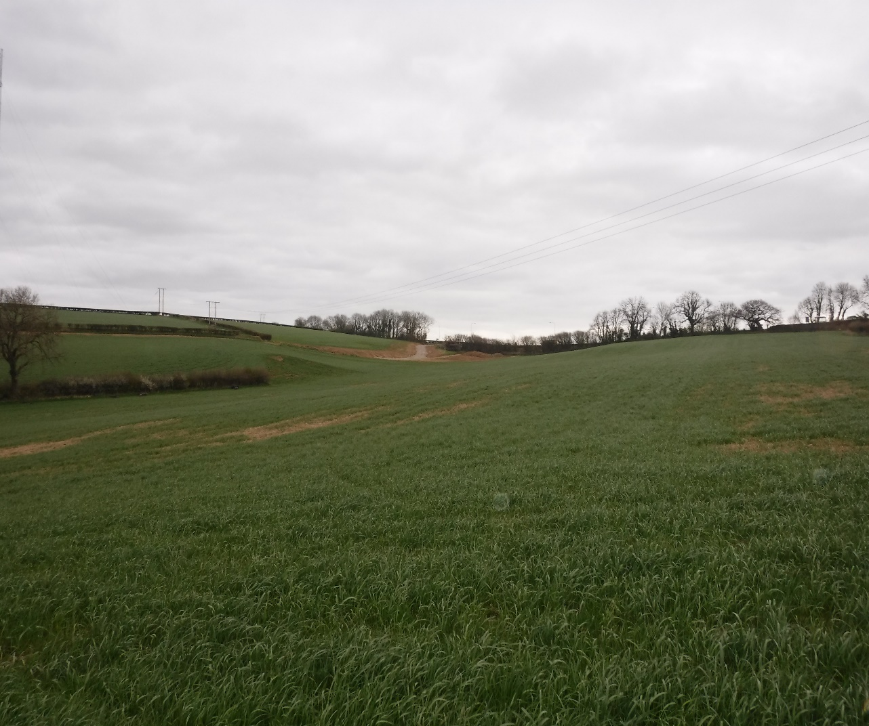
View of Lake Site from lower North East corner of field (looking towards the A48)

View of site from Entrance off the A48 with approved access to fore
Site
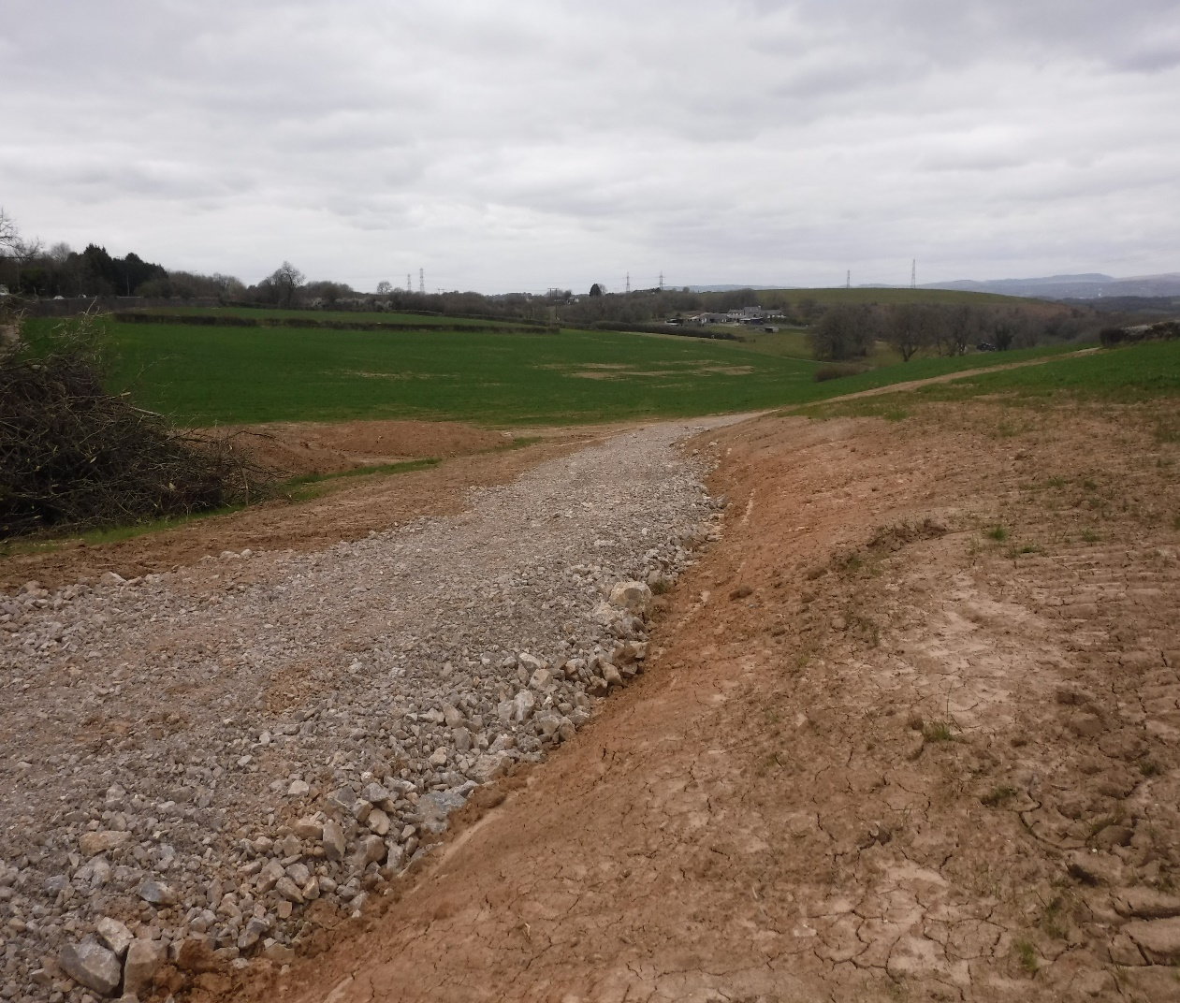
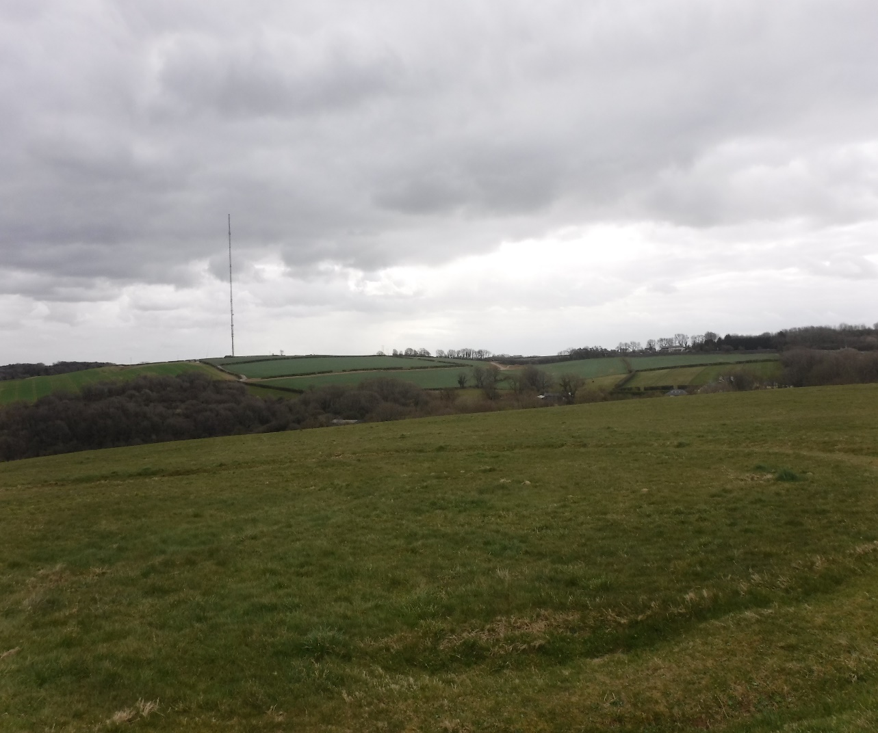
Site
View of Lake Site from Stalling Down (distant fields to right hand side of new farm track and Radio Aerial)
- The site is separated from the A48 by a mature dense hedgerow. Other than through the opening caused by the new access, the lakes would not be visible from the A48. A view of the site will be possible from Stalling Down some 600 m to the south east which affords panoramic views of the locality.

- The land has recently been purchased by the applicant and it was formerly used for arable cropping and pasture with no notable bio-diversity interest. An ecology walk over survey has been undertaken and is forwarded.

- There are no environmental, heritage or archaeological constraints identified at this site or nearby based on DEFRA’s MAGIC Map. The Llanquian Wood Heritage site is more than 150 m to the north.
- The site is set down within the upper slopes of a shallow valley and would be seen from Stalling down as a semi natural wet land site. The Fishing Lakes do make a change to the character of the site but one that has a natural appearance and one that blends in with the rolling landscape character of the site and locality. The Lakes and Redd Beds will add much bio-diversity value to the site. Detailed ecological and landscape assessments have been undertaken which are submitted with the pre-application report.

22. Appearance – The Lakes are formed following the natural ground contours within a shallow north west facing valley. When mature it will resemble a natural feature adding bio-diversity and rural enterprise to Pant Wilkin Stables. The fishing pontoons are wooden and float on the water. The Cabin is finished in timber boarding beneath a green felted type roof. The parking and turning area is finished in hardcore and the access track is existing. Landscaping makes use of indigenous species.

23. Context - The main valley through Pant Wilkin accommodates the Lower Racing Yard and is unsuitable for a fishing enterprise of the scale proposed. The proposed site is a natural shallow valley facing north west which can accommodate a series of fishing lakes using natural earth bunds a short distance from the A48. There are no near neighbours or conflict with PROW or sites of environmental importance. The sub soil was found to have insufficient clay to form a sealed base for the lakes so some imported clay will eb used for that purpose. A topographical survey has been undertaken of the site and its environs and cross sections through the site have been undertaken and forwarded with the pre-application report.

24. Use – The proposed use is commercial fishing lakes to help diversify the Pant Wilkin Farm Stables enterprise. It is to be all year round and to include night fishing as that attracts the more serious fishermen.

Annexes
Annexes A and B give relevant policies and the Thaw SLA descriptions.
BRIAN GRIFIFN FRICS FAAV
Chartered Surveyor
APPENDIX A
PLANNING POLICIES
Local Development Plan:
Section 38 of The Planning and Compulsory Purchase Act 2004 requires that in
determining a planning application the determination must be in accordance with the
Development Plan unless material considerations indicate otherwise. The Vale of
Glamorgan Adopted Local Development Plan 2011-2026 forms the local authority
level tier of the development plan framework. The LDP was formally adopted by the
Council on 28 June 2017, and within which the following policies are of relevance:

Strategic Policies:
POLICY SP1 – Delivering the Strategy
POLICY SP9 – Minerals
POLICY SP10 – Built and Natural Environment
POLICY SP11 – Tourism and Leisure

Managing Growth Policies:
POLICY MG17 – Special Landscape Areas
POLICY MG19 – Sites and Species of European Importance
POLICY MG20 – Nationally Protected Sites and Species
POLICY MG21 – Sites of Importance for Nature Conservation, Regionally Important
Geological and Geomorphological Sites and Priority Habitats and Species
POLICY MG22 – Development in Minerals Safeguarding Areas
POLICY MG29 – Tourism and Leisure Facilities

Managing Development Policies:
POLICY MD1 - Location of New Development
POLICY MD2 - Design of New Development
POLICY MD7 - Environmental Protection
POLICY MD8 - Historic Environment
POLICY MD9 - Promoting Biodiversity
POLICY MD13 - Tourism and Leisure
POLICY MD17 - Rural Enterprise

In addition to the Adopted LDP the following policy, guidance and documentation
supports the relevant LDP policies.

Future Wales: The National Plan 2040:
Future Wales – the National Plan 2040 is the national development plan and is of
relevance to the determination of this proposal. Future Wales provides a strategic
direction for all scales of planning and sets out policies and key issues to be
considered in the planning decision making process. The following chapters and
policies are of relevance in the assessment of this proposal:

Chapter 3: Setting and achieving our ambitions
· 11 Future Wales’ outcomes are overarching ambitions based on the national
planning principles and national sustainable placemaking outcomes set out in
Planning Policy Wales.

Chapter 5 – The Regions
· The Vale of Glamorgan falls within the South East region.
· Regional policies provide a framework for national growth, for regional growth,
for managing growth and supporting growth.
· In the absence of SDPs, development management process needs to
demonstrate how Future Wales’ regional policies have been taken into
account.
Policy 4 – Supporting Rural Communities
o Supports sustainable and vibrant rural communities.
Policy 5 – Supporting the Rural Economy
o Supports sustainable, appropriate and proportionate economic growth
in rural towns.
o Supports development of innovative and emerging technology
businesses and sectors to help rural areas unlock their full potential,
broadening the economic base and creating higher paid jobs.
Policy 9 – Resilient Ecological Networks and Green Infrastructure
o Action towards securing the maintenance and enhancement of
biodiversity (to provide a net benefit), the resilience of ecosystems and
green infrastructure assets must be demonstrated as part of
development proposals through innovative, nature-based approaches
to site planning and the design of the built environment.
Policy 12- Regional Connectivity
o Active travel must be an essential and integral component of all new
developments.
o Where car parking is provided for new non-residential development a
minimum of 10% of car parking spaces should have electric vehicle
charging points.

Planning Policy Wales:

National planning policy in the form of Planning Policy Wales (Edition 11, 2021)
(PPW) is of relevance to this proposal.
The primary objective of PPW is to ensure that the planning system contributes
towards the delivery of sustainable development and improves the social, economic,
environmental and cultural well-being of Wales.
The following chapters and sections are of particular relevance in the assessment of
this proposal:

Chapter 2 - People and Places: Achieving Well-being Through Placemaking
· Maximising well-being and sustainable places through placemaking (key
Planning Principles, national sustainable placemaking outcomes, Planning
Policy Wales and placemaking)

Chapter 3 - Strategic and Spatial Choices
· Good Design Making Better Places
· Placemaking in Rural Areas
· Accessibility
· The Best and Most Versatile Agricultural Land
· Development in the Countryside (including new housing)
· Supporting Infrastructure
· Managing Settlement Form –Green Wedges

Chapter 4 - Active and Social Places
· Transport
· Recreational Spaces

Chapter 5 - Productive and Enterprising Places
· Economic Infrastructure (electronic communications, transportation
Infrastructure, economic development, tourism and the Rural Economy)

Chapter 6 - Distinctive and Natural Places
· Recognising the Special Characteristics of Places (The Historic Environment,
Green Infrastructure, Landscape, Biodiversity and Ecological Networks,
Coastal Areas)
· Recognising the Environmental Qualities of Places (water and flood risk, air
quality and soundscape, lighting, unlocking potential by taking a de-risking
approach)

Technical Advice Notes:
The Welsh Government has provided additional guidance in the form of Technical
Advice Notes. The following are of relevance:

• Technical Advice Note 5 – Nature Conservation and Planning (2009)
• Technical Advice Note 6 – Planning for Sustainable Rural Communities
• Technical Advice Note 12 – Design (2016)
• Technical Advice Note 13 – Tourism (1997)
• Technical Advice Note 16 - Sport, Recreation and Open Space (2009)
• Technical Advice Note 18 – Transport (2007)
• Technical Advice Note 23 – Economic Development (2014)
• Technical Advice Note 24 – The Historic Environment (2017)

Welsh National Marine Plan:
National marine planning policy is in the form of the Welsh National Marine Plan
(2019) (WNMP). The primary objective of WNMP is to ensure that the planning
system contributes towards the delivery of sustainable development and contributes
to the Wales well-being goals within the Marine Plan Area for Wales. WNMP is of
limited relevance in the assessment of this proposal.

Supplementary Planning Guidance:
In addition to the adopted Local Development Plan, the Council has approved
Supplementary Planning Guidance (SPG). Some SPG documents refer to previous
adopted UDP policies and to ensure conformity with LDP policies, a review is to be
carried out as soon as is practicable following adoption of the LDP. The Council
considers that the content and guidance of the adopted SPGs remains relevant and
has approved the continued use of these SPGs as material considerations in the
determination of planning applications until they are replaced or otherwise
withdrawn.
The following SPG are of relevance:
• Biodiversity and Development (2018)
• Design in the Landscape (2006)
• Minerals Safeguarding (2018)
• Parking Standards (2019)
• Sustainable Development - A Developer's Guide (2006)
• Tourism and Leisure Development (2019)
• Travel Plan (2018)
• Trees, Woodlands, Hedgerows and Development (2018)

Other relevant evidence or policy guidance:
· Welsh Government Circular 016/2014: The Use of Planning Conditions for
Development Management

Well-being of Future Generations (Wales) Act 2015
The Well-being of Future Generations Act (Wales) 2015 places a duty on the Council
to take reasonable steps in exercising its functions to meet its sustainable
development (or wellbeing) objectives. The document has been prepared in
consideration of the Council’s duty and the “sustainable development principle”, as
set out in the 2015 Act. In preparing the advice, the Council has sought
to ensure that the needs of the present are met without compromising the ability of
future generations to meet their own needs.
The main development control polices are:
POLICY SP1 - DELIVERING THE STRATEGY The strategy will seek to improve the living and working environment, promote enjoyment of the countryside and coast and manage important environmental assets. This will be achieved by: 1. Providing a range and choice of housing to meet the needs of all sectors of the community; 2. Promoting a range of employment sites intended to meet the needs of the Vale of Glamorgan and the wider capital region; 3. Reinforcing the role of Barry, service centre settlements and primary settlements as providers of cultural, commercial and community services; 4. Promoting sustainable transport; 5. Delivering key infrastructure linked to the impacts of development; 6. Protecting and enhancing the built, natural and coastal environment; LDP Strategy 3The Town and Country Planning (Local Development Plan)(Wales) Regulations 2005 Vale of Glamorgan Local Development Plan 2011 - 2026 : Written Statement 39 7 Promoting opportunities for sustainable tourism and recreation;
POLICY SP9 - MINERALS The local and regional need for the provision of a continuous supply of minerals will be achieved through: 1. Maintaining a minimum of 10 years land bank of hard rock throughout the plan period; including extended time periods to complete permitted extraction at existing sites; 2. Favouring proposals which promote the sustainable use of minerals and encourage the use of secondary and alternative resources; 3. The safeguarding of known resources of sandstone, limestone, sand and gravel (where these occur outside settlements), from permanent development that would unnecessarily sterilise them or hinder their future extraction; and 4. Safeguarding wharf facilities for the landing of marine dredged sand & gravel. d 8. Favouring development that promotes healthy living.
POLICY SP10 - BUILT AND NATURAL ENVIRONMENT Development proposals must
preserve and where appropriate enhance the rich and diverse built and natural environment and heritage of the Vale of Glamorgan including: 1. The architectural and / or historic qualities of buildings or conservation areas, including locally listed buildings; 2. Historic landscapes, parks and gardens; 3. Special landscape areas; 4. The Glamorgan Heritage Coast; 5. Sites designated for their local, national and European nature conservation importance; and 6.
Important archaeological and geological features.
POLICY SP11 - TOURISM AND LEISURE Proposals which promote the Vale of Glamorgan as a tourism and leisure destination will be favoured. Existing tourism and leisure facilities will be protected and enhanced, and favourable consideration will be given to proposals which: 1. Enhance the range and choice of the Vale of Glamorgan’s tourism and leisure opportunities, particularly through the provision of all year round facilities and a range and choice of visitor accommodation in appropriate locations; 2. Favour rural diversification and the local economy; and 3. Protect existing tourism assets and promote the sustainable use of the countryside and the Glamorgan Heritage Coast.
POLICY MG17 - SPECIAL LANDSCAPE AREAS The following areas are designated as special landscape areas: 1. Castle Upon Alun; 2. Upper & Lower Thaw Valley; 3. Ely Valley & ridge slopes; 4. Nant Llancarfan; 5. Dyffryn basin & ridge slopes; 6. Cwrt-yr-Ala basin. Within the special landscape areas identified above, development proposals will be permitted where it is demonstrated they would cause no unacceptable harm to the important landscape character of the area.
POLICY MG19 - SITES AND SPECIES OF EUROPEAN IMPORTANCE Development proposals likely to have a significant effect on a European site, when considered alone or in combination with other projects or plans will only be permitted where: 1. The proposal is directly connected with or necessary for the protection, enhancement and positive management of the site for conservation purpose; or 2. The proposal will not adversely affect the integrity of the site; 3. There is no alternative solution; 4. There are reasons of overriding public interest; and 5. Appropriate compensatory measures are secured. Managing Growth in the Vale of Glamorgan 20PPW Edition 9 (November 2016) paragraphs 4.8.14 to 4.8.18. 86 Vale of Glamorgan Local Development Plan 2011 - 2026 : Written Statement Contents Development proposals likely to have an adverse effect on a European protected species will only be permitted where: 1. There are reasons of overriding public interest; 2. There is no satisfactory alternative; and 3. The action authorised will not be detrimental to the maintenance of the population of the species concerned at a favourable conservation status in their natural range.
POLICY MG20 – NATIONALLY PROTECTED SITES AND SPECIES Development likely to have an adverse effect either directly or indirectly on the conservation value of a site of special scientific interest will only be permitted where it is demonstrated that: 1. There is no suitable alternative to the proposed development; and 2. It can be demonstrated that the benefits from the development clearly outweigh the special interest of the site; and 3. Appropriate compensatory measures are secured; or 4. The proposal contributes to the protection, enhancement or positive management of the site. Development proposals likely to affect protected species will only be permitted where it is demonstrated that: 1. The population range and distribution of the species will not be adversely impacted; 2. There is no suitable alternative to the proposed development; 3. The benefits of the development clearly outweigh the adverse impacts on the protected species; and 4. Appropriate avoidance, mitigation and compensation measures are provided.
POLICY MG21 – SITES OF IMPORTANCE FOR NATURE CONSERVATION, REGIONALLY IMPORTANT GEOLOGICAL AND GEOMORPHOLOGICAL SITES AND PRIORITY HABITATS AND SPECIES Development proposals likely to have an adverse impact on sites of importance for nature conservation or priority habitats and species will only be permitted where it can be demonstrated that: 1. The need for the development clearly outweighs the nature conservation value of the site; 2. Adverse impacts on nature conservation and geological features can be avoided; 3. Appropriate and proportionate mitigation and compensation measures can be provided; and 4. The development conserves and where possible enhances biodiversity interests.
POLICY MD1 - LOCATION OF NEW DEVELOPMENT New development on unallocated sites should: 1. Have no unacceptable impact on the countryside; 2. Reinforce the role and function of the key settlement of Barry, the service centre settlements, primary settlements or minor rural settlements as key providers of commercial, community and healthcare facilities; 3. Where appropriate promote new enterprises, tourism, leisure and community facilities in the Vale of Glamorgan; 4. In the case of residential development, support the delivery of affordable housing in areas of identified need; 5. Have access to or promote the use of sustainable modes of transport; 6. Benefit from existing infrastructure provision or where necessary make provision for new infrastructure without any unacceptable effect on the natural or built environment; 7. Where possible promote sustainable construction and make beneficial use of previously developed land and buildings; 8. Provide a positive context for the management of the water environment by avoiding areas of flood risk in accordance with the sequential approach set out in national policy and safeguard water resources; and 9. Have no unacceptable impact on the best and most versatile agricultural land.
POLICY MG22 - DEVELOPMENT IN MINERAL SAFEGUARDING AREAS Known mineral resources of sandstone, sand and gravel and limestone are safeguarded as shown on the proposals map. New development will only be permitted in an area of known mineral resource where it has first been demonstrated that: 1. Any reserves of minerals can be economically extracted prior to the commencement of the development; 2. Or extraction would have an unacceptable impact on environmental or amenity considerations; or 3. The development would have no significant impact on the possible working of the resource by reason of its nature or size; or 4. The resource in question is of poor quality / quantity.
POLICY MG29 - TOURISM AND LEISURE FACILITIES The provision of all year round tourism and leisure facilities will be favoured. Land is allocated at the following locations for tourism related development: 1. Barry Island Pleasure Park, Whitmore Bay; 2. Land at Nell’s Point, Whitmore Bay; and 3. Land at Cottrell Park Golf Course
POLICY MD1 - LOCATION OF NEW DEVELOPMENT New development on unallocated sites should: 1. Have no unacceptable impact on the countryside; 2. Reinforce the role and function of the key settlement of Barry, the service centre settlements, primary settlements or minor rural settlements as key providers of commercial, community and healthcare facilities; 3. Where appropriate promote new enterprises, tourism, leisure and community facilities in the Vale of Glamorgan; 4. In the case of residential development, support the delivery of affordable housing in areas of identified need; 5. Have access to or promote the use of sustainable modes of transport; 6. Benefit from existing infrastructure provision or where necessary make provision for new infrastructure without any unacceptable effect on the natural or built environment; 7. Where possible promote sustainable construction and make beneficial use of previously developed land and buildings; 8. Provide a positive context for the management of the water environment by avoiding areas of flood risk in accordance with the sequential approach set out in national policy and safeguard water resources; and 9. Have no unacceptable impact on the best and most versatile agricultural land.
POLICY MD2 - DESIGN OF NEW DEVELOPMENT In order to create high quality, healthy, sustainable and locally distinct places development proposals should: 1. Be of a high standard of design that positively contributes to the context and character of the surrounding natural and built environment and protects existing features of townscape or landscape interest; 2. Respond appropriately to the local context and character of neighbouring buildings and uses in terms of use, type, form, scale, mix, and density; 3. Where appropriate, provide new or enhanced areas of public realm particularly in key locations such as town centres, major routes and junctions; 4. Promote the creation of healthy and active environments and reduce the opportunity for crime and anti-social behaviour. In the case of retail centres, developments should provide active street frontages to create attractive and safe urban environments; 5. Provide a safe and accessible environment for all users, giving priority to pedestrians, cyclists and public transport users; 6. Have no unacceptable impact on highway safety nor cause or exacerbate existing traffic congestion to an unacceptable degree; 7. Where appropriate, conserve and enhance the quality of, and access to, existing open spaces and community facilities; 8. Safeguard existing public and residential amenity, particularly with regard to privacy, overlooking, security, noise and disturbance; 9. Provide public open space, private amenity space and car parking in accordance with the council’s standards; 10. Incorporate sensitive landscaping, including the retention and enhancement where appropriate of existing landscape features and biodiversity interests; 11. Provide adequate facilities and space for the collection, composting and recycling of waste materials and explore opportunities to incorporate re-used or recyclable materials or products into new buildings or structures; and 12. Mitigate the causes of climate change by minimising carbon and other greenhouse gas emissions associated with their design, construction, use and eventual demolition, and include features that provide effective adaptation to, and resilience against, the current and predicted future effects of climate change.
POLICY MD7 - ENVIRONMENTAL PROTECTION Development proposals will be required to demonstrate they will not result in an unacceptable impact on people, residential amenity, property and / or the natural environment from either: 1. Pollution of land, surface water, ground water and the air; 2. Land contamination; 3. Hazardous substances; 4. Noise, vibration, odour nuisance and light pollution; 5. Flood risk and consequences; 6. Coastal erosion or land stability; 7. The loss of the best and most versatile agricultural land; or 8. Any other identified risk to public health and safety. Where impacts are identified the Council will require applicants to demonstrate that appropriate measures can be taken to minimise the impact identified to an acceptable level. Planning conditions may be imposed or legal obligation entered into, to secure any necessary mitigation and monitoring processes. In respect of flood risk, new developments will be expected to avoid unnecessary flood risk and meet the requirements of TAN15. No highly vulnerable development will be permitted within Development Advice Map (DAM) zone C2. Development will only be permitted in areas at risk of flooding where it can be demonstrated that the site can comply with the justification and assessment requirements set out in TAN15.
POLICY MD8 - HISTORIC ENVIRONMENT Development proposals must protect the qualities of the built and historic environment of the Vale of Glamorgan, specifically: 1. Within conservation areas, development proposals must preserve or enhance the character or appearance of the area; 2. For listed and locally listed buildings, development proposals must preserve or enhance the building, its setting and any features of significance it possesses; 3. Within designated landscapes, historic parks and gardens, and battlefields, development proposals must respect the special historic character and quality of these areas, their settings or historic views or vistas; 4. For sites of archaeological interest, development proposals must preserve or enhance archaeological remains and where appropriate their settings.
POLICY MD9 - PROMOTING BIODIVERSITY New development proposals will be required to conserve and where appropriate enhance biodiversity interests unless it can be demonstrated that: 1. The need for the development clearly outweighs the biodiversity value of the site; and 2. The impacts of the development can be satisfactorily mitigated and acceptably managed through appropriate future management regimes.
POLICY MD13 - TOURISM AND LEISURE Proposals for the development of new or enhanced tourism and leisure facilities will be permitted where the proposal: 1. Is located within the key settlement, the service centre settlements, primary settlements and minor rural settlements; or Managing Development in the Vale of Glamorgan Vale of Glamorgan Local Development Plan 2011 - 2026 : Written Statement 117 2. Forms part of a rural enterprise or farm diversification scheme; or 3. Involves the conversion of an existing rural building in accordance with Policy MD11; or 4. Involves sustainable low impact tourism and leisure proposals in the countryside; and Proposals that would result in the loss of existing tourism and leisure facilities will be resisted unless it can be demonstrated that there is a sufficient supply of facilities within the area to satisfy demand and/or the facility has been marketed and proven to be no longer economically viable.

POLICY MD17 - RURAL ENTERPRISE Proposals for the development of small scale employment uses that promote rural enterprise will be permitted where the proposal: 1. Is located within a minor rural settlement; or 2. Is part of a farm diversification scheme; or 3. Involves the conversion of an existing rural building in accordance with policy MD11. Proposals that would result in the loss of existing small scale employment uses will be assessed in accordance with acknowledges that there may be instances where sensitive infilling or minor extensions to groups of dwellings may be acceptable (in particular for affordable housing to meet local need).
Proposals for such development will be assessed against this national policy framework. Where new development is justified in the open countryside, relevant LDP policies will also apply such as Policies MD2 Design of New Development and MD10 Affordable Housing. In addition, national policy also makes provision for new rural enterprise dwellings and ‘one planet developments’ as exceptions for residential development in the open countryside and clear guidance on these types of development in set out in TAN 6 Planning for Sustainable Rural Communities (July 2010).”

ANNEX B Upper and Lower Thaw SLA
The north side of the valley through which Nant Aberthin runs is not covered by a high quality landscape policy. The southern side of the valley is designated as a SLA (Upper and Lower Thaw SLA.) The description of the SLA in the Council’s documents state:
To the north, the area is sparsely settled with small villages and several farms. The generally open landscape has high intervisibility and overlooks Bridgend, bordering the M4, and colouring the perception of the area. Mynydd Maendy wind farm to the north also has a visual impact on the sense of place. There are a number of pleasant views to well-managed fields and wooded areas, but these are affected in places by gappy hedgerows and housing development. Trees and hedgerows are declining in the area but introducing blocks of broadleaf woodland would help to integrate settlement, whilst future development should be restricted in widely visible areas. The dramatic valley form has distinctive steep wooded slopes and a strong sense of place and is relatively uncommon. It
is enclosed by a plateau landscape and has a strong relationship with Cowbridge.
The SLA boundary excludes Cowbridge, the suburbs of which are eroding the rural character. The town centre areas of historic and aesthetic value are protected by Conservation Area status. The valley to the south is a confined, sinuous lowland valley with steep wooded sides and hedgerowed field valley floor with streams and wet ditches contributing to biodiversity. The strong valley, semi-natural and planted broadleaf woodland, and juxtaposition with valley settlements is very attractive and one of the best examples of this landscape in the Vale. Woodland is fragmented in places and linkages should be created by pursuing the Forestry Commission’s Woodland Grant Scheme and Native Woodland Plans. Elsewhere the landscape is rolling lowland with some views out to the coast.
Key Policy and Management Issues
- Maintain hedgerow and tree cover.
- Incorporate agri-environment schemes.
- Improve development to ensure rural detailing and character.
- Restrict development in widely visible areas and introduce blocks of broadleaf woodland to integrate settlement/Ford related development.
- Encourage woodland management for continuous cover and pursue Forestry Commission Woodland Grant Schemes and Native Woodland Plans.
5.2 The Evaluation Matrix for the SLA rates the SLA area (which does not include the application site or the near surrounding land) the following rating:
Geological GL 282 High M M M L GL 298 Moderate H M H M GL 492 Outstanding O O
O O GL 514 Moderate M L L L GL 532 High H M M M GL 630 Moderate L L L L GL 658 High H M M M GL 709 Moderate L L L L GL 863 Moderate M M H M
Landscape Habitats LH 103 Low U U U U U U L M LH 118 Moderate L L H U L M M H LH 394 High H M U U U M H U LH 435 Moderate M L H U L L M U LH 436 High
H M U U U M H H LH 782 High H H U U U H H U LH 808 Moderate H H U U H M M H
Visual and Sensory VS 139 High H H H H VS 146 Moderate M M M M VS 161
Moderate M M M M VS 805 Moderate M M M M VS 864 Moderate M M H M VS
933 High H M H H VS 943 Moderate M M M M VS 962 Moderate H M M M
Historical Landscapes HL 022 Outstanding O O H H H HL 032 Outstanding O O H M O
HL 039 Outstanding O O M O O HL 040 Outstanding O O H O O HL 041
Outstanding O O O O O HL 042 High H H H L H HL 046 High H H H H M HL
047 High H H M M H HL 048 High H H H M M HL 049 High H H M L O HL 052 High H H M M H HL 053 Moderate M M M L M HL 054 High H H M M H
Cultural CL 008 Outstanding H M O U H H L H U CL 020 Outstanding H H L O H U M
U U CL 028 Outstanding M H L M O H L L U CL 037 Outstanding M H L M O H
L L U CL 039 High H O L U O H L H L

